**Creating 2 EC2 Instances**

1. Open the Amazon EC2 console.
2. Select Launch Instance.
3. Choose an Amazon Machine Image (AMI), find an Amazon Linux AMI at the top of the list and choose Select.
4. Choose an Instance Type, choose Next: Configure Instance Details.
5. Configure Instance Details, choose Network, and then choose the entry for your default VPC. Choose Subnet, and then choose a subnet in any Availability Zone.Choose Next: Add Storage.
6. After that, Add Tags.
7. Name your instance and choose Next: Configure Security Group.
8. Configure Security Group, review the contents of this page, ensure that Assign a security group is set to Create a new security group, and verify that the inbound rule being created has the following default values.
9. Choose Review and Launch.
10. Click on Launch.

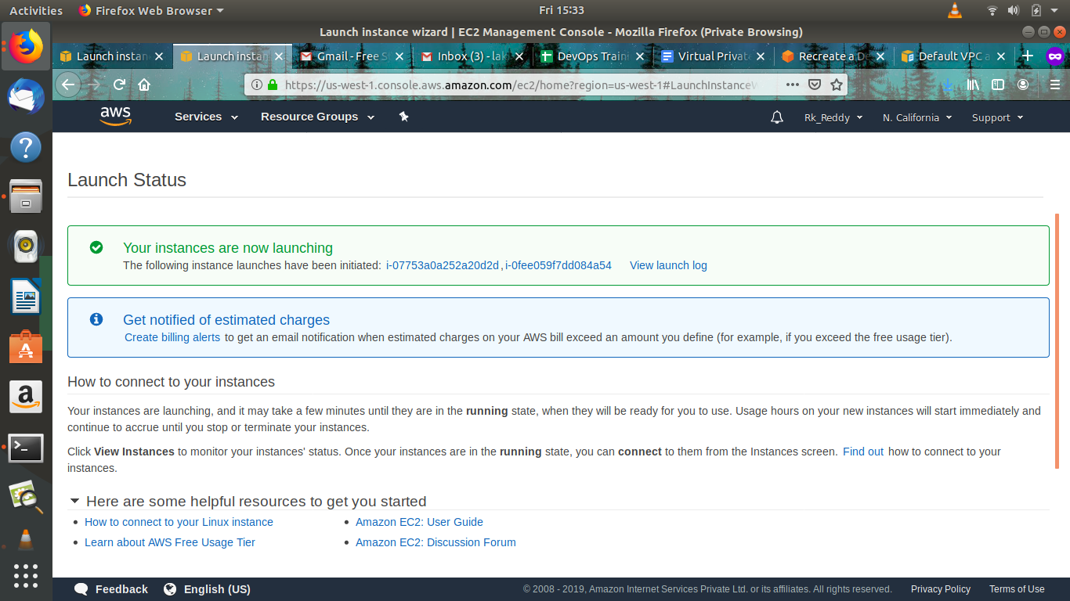

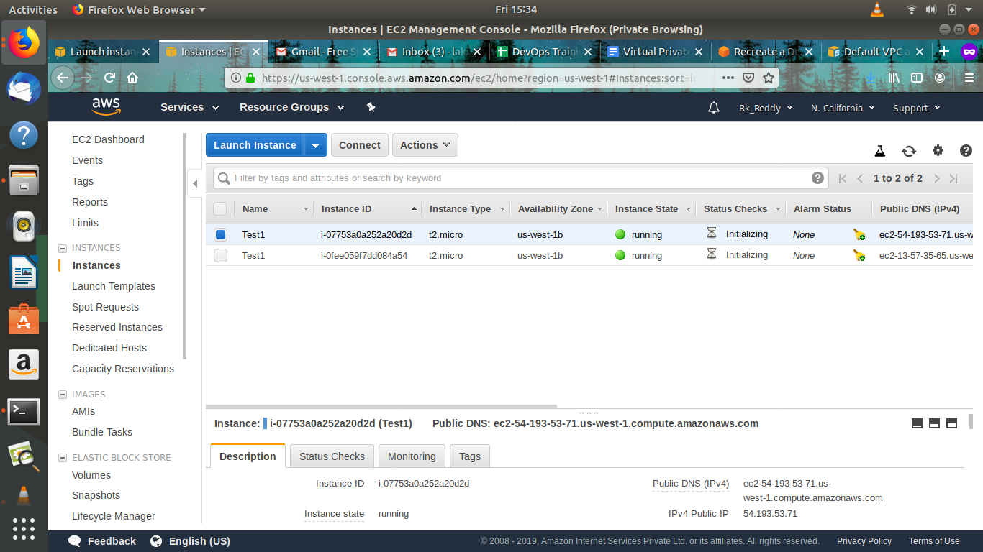

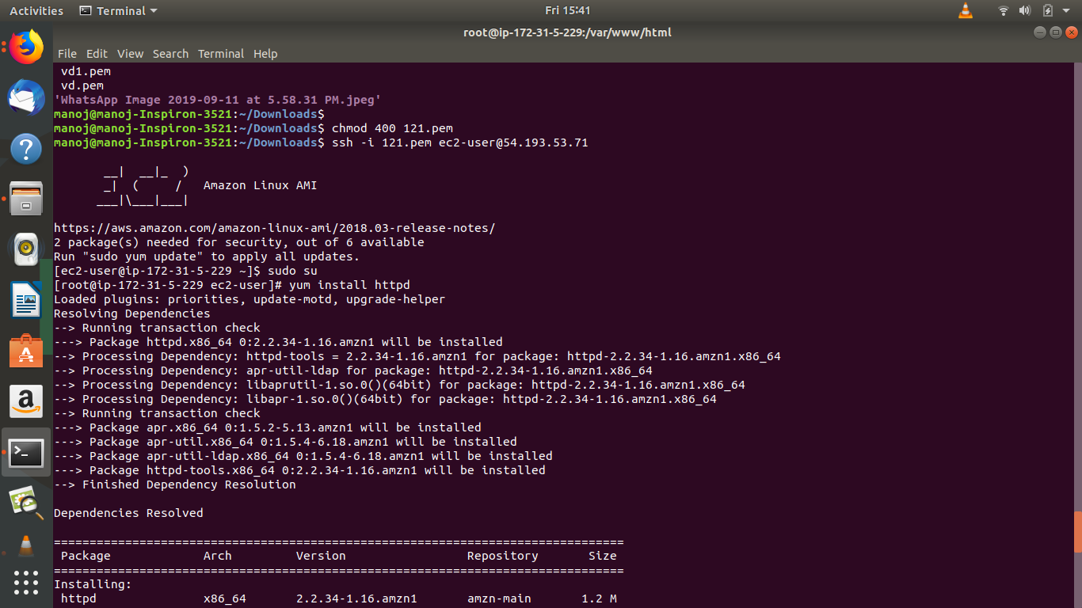

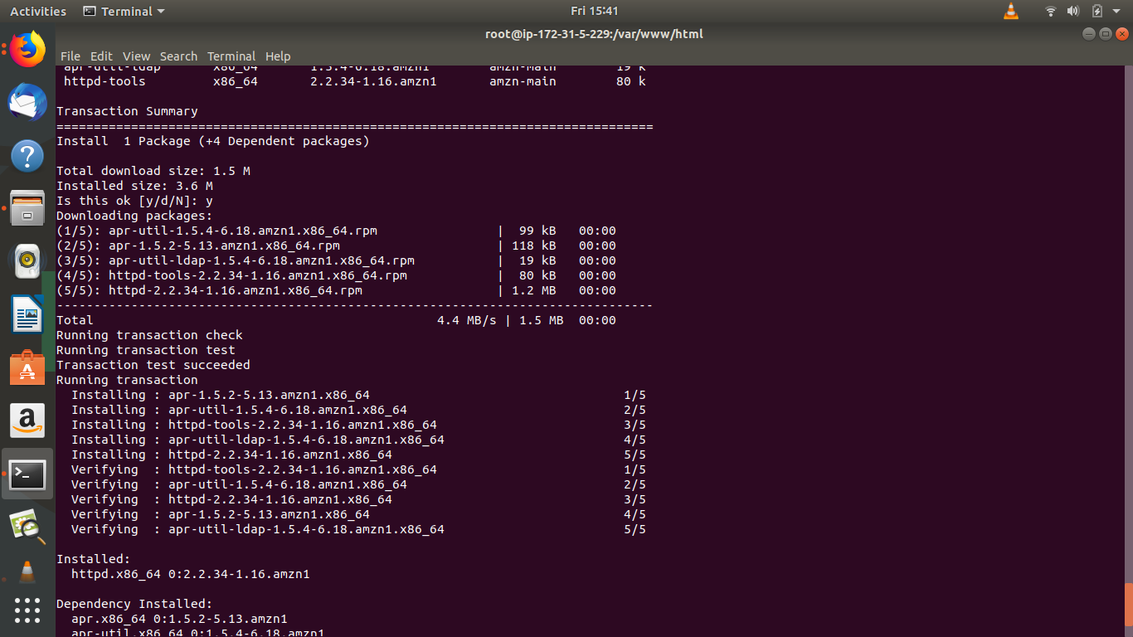

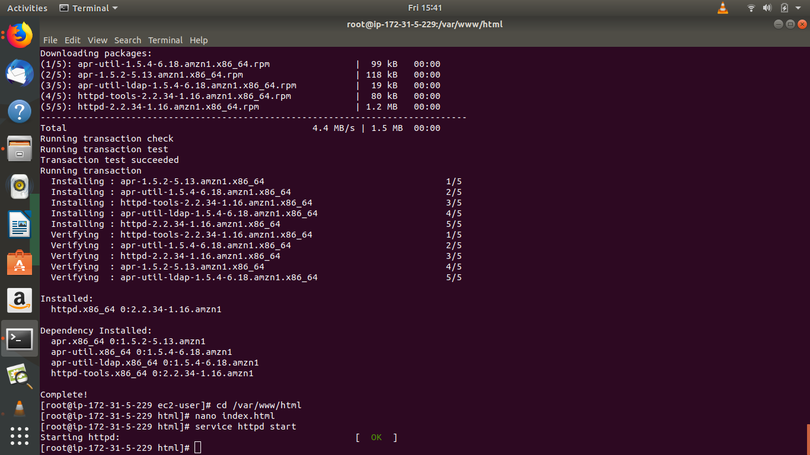

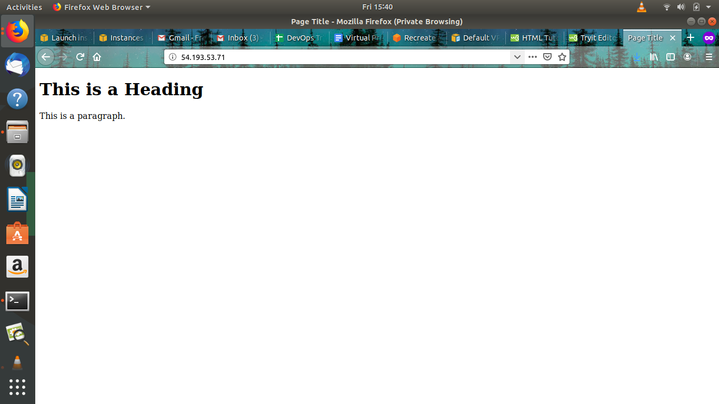

**2.Creating alarms in Cloud Watch.**

Amazon CloudWatch monitors your Amazon Web Services (AWS) resources and the applications you run on AWS in real time. You can use CloudWatch to collect and track metrics, which are variables you can measure for your resources and applications.The CloudWatch home page automatically displays metrics about every AWS service you use. You can additionally create custom dashboards to display metrics about your custom applications, and display custom collections of metrics that you choose. You can create alarms which watch metrics and send notifications or automatically make changes to the resources you are monitoring when a threshold is breached. For example, you can monitor the CPU usage and disk reads and writes of your Amazon EC2 instances and then use this data to determine whether you should launch additional instances to handle increased load. You can also use this data to stop under-used instances to save money.With CloudWatch, you gain system-wide visibility into resource utilization,application performance, and operational health.

1. Here, I created a cloud watch alarm for CPU usage. Whenever it reaches its threshold value which sends you an alarm email.

2.Here I put some stress on CPU so that it will reach its threshold value

Sudo su

Yum install stress

Stress --cpu 8 --timeout 300

Whenever it reaches threshold value using sns it will send an email.

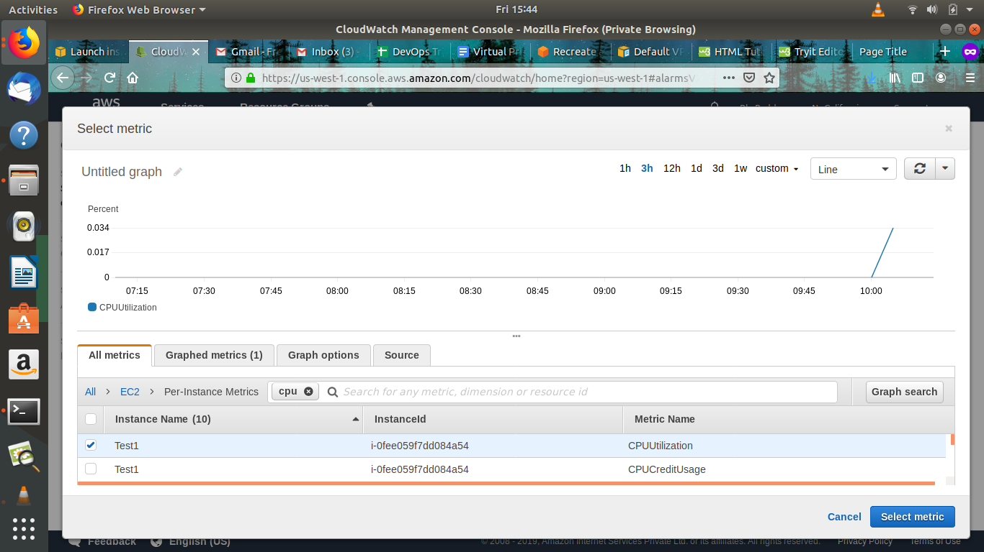  
  
  
  
  
  
  
  
  
  
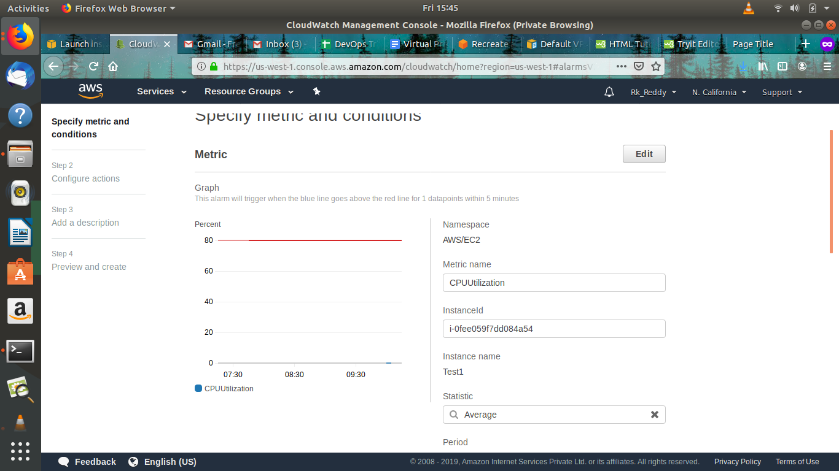  
  
  
  
  
  
  
  
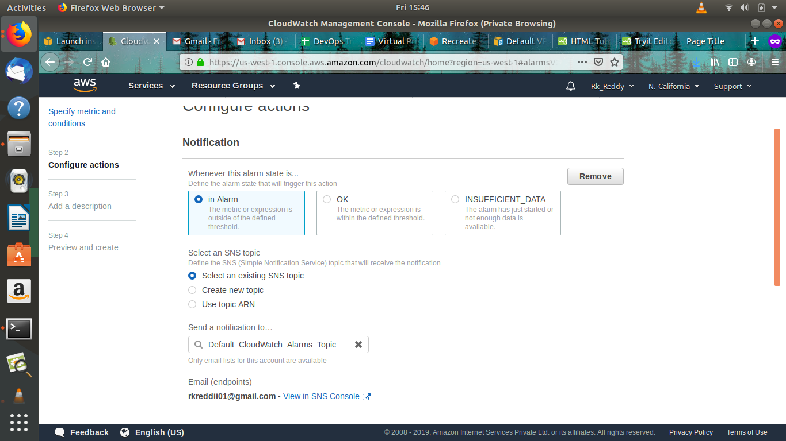  
  
  
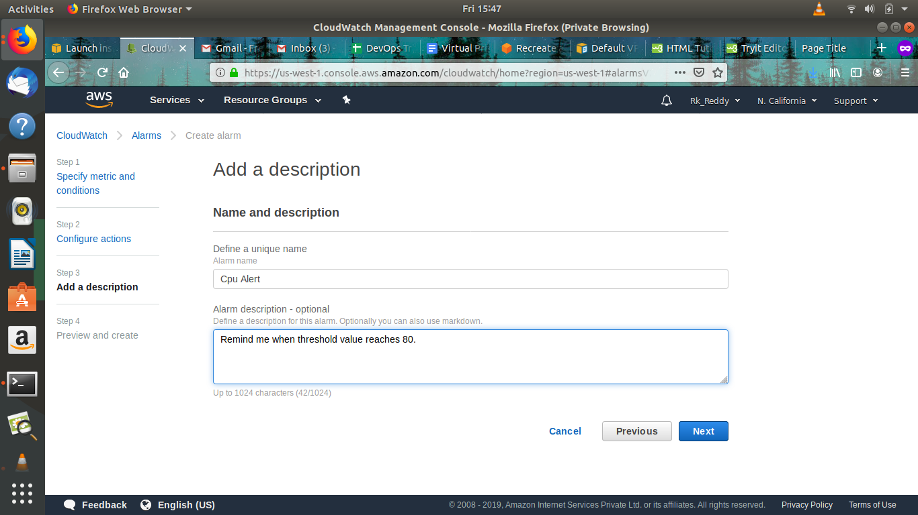  
  
  
  
  
  
  
  
  
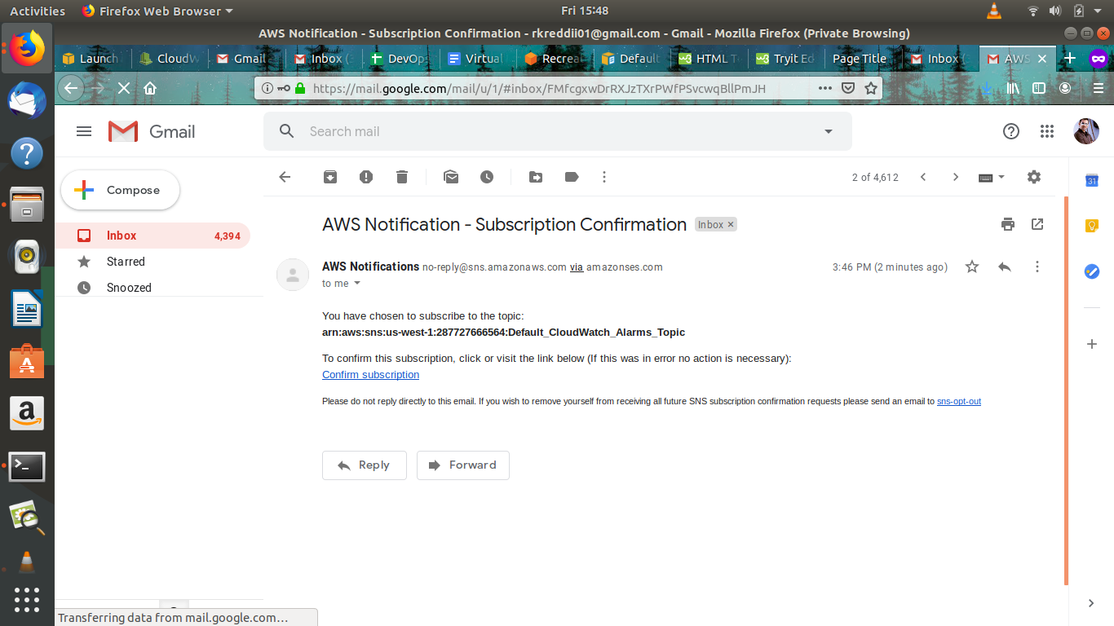  
  
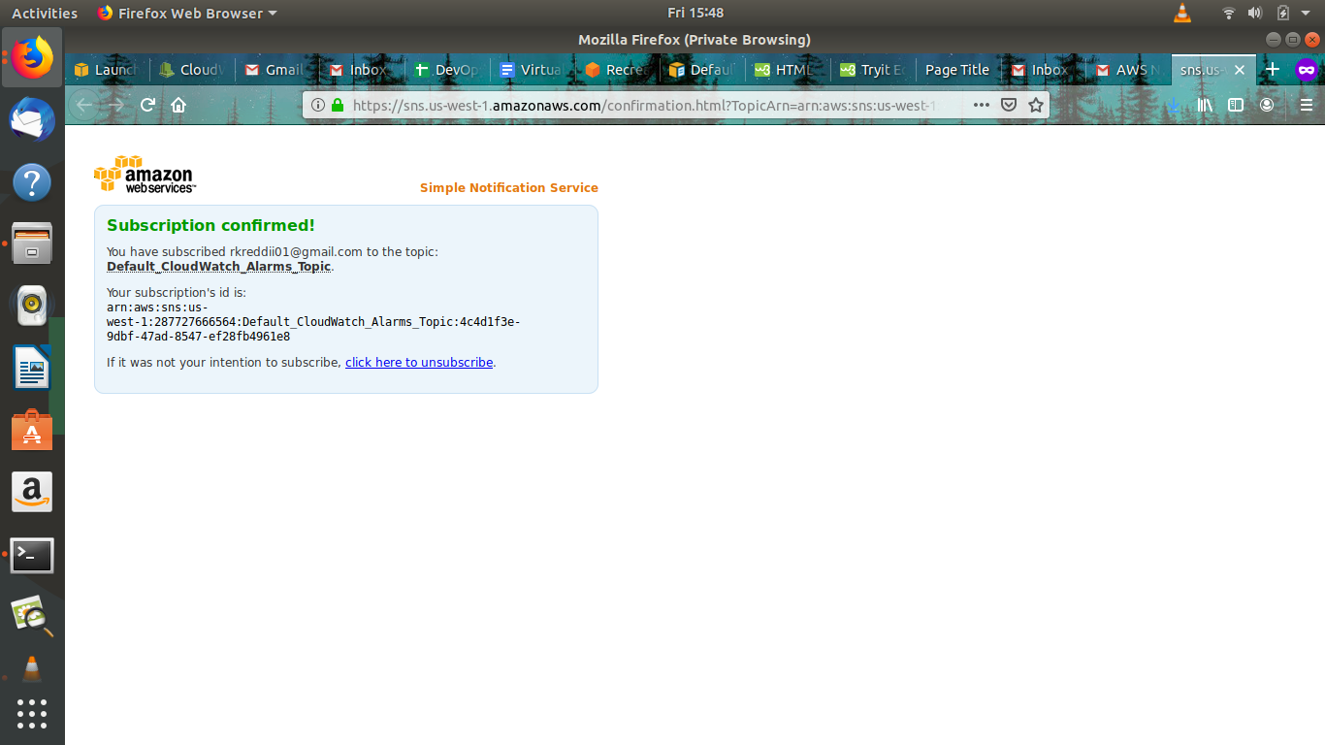  
  
  
  
  
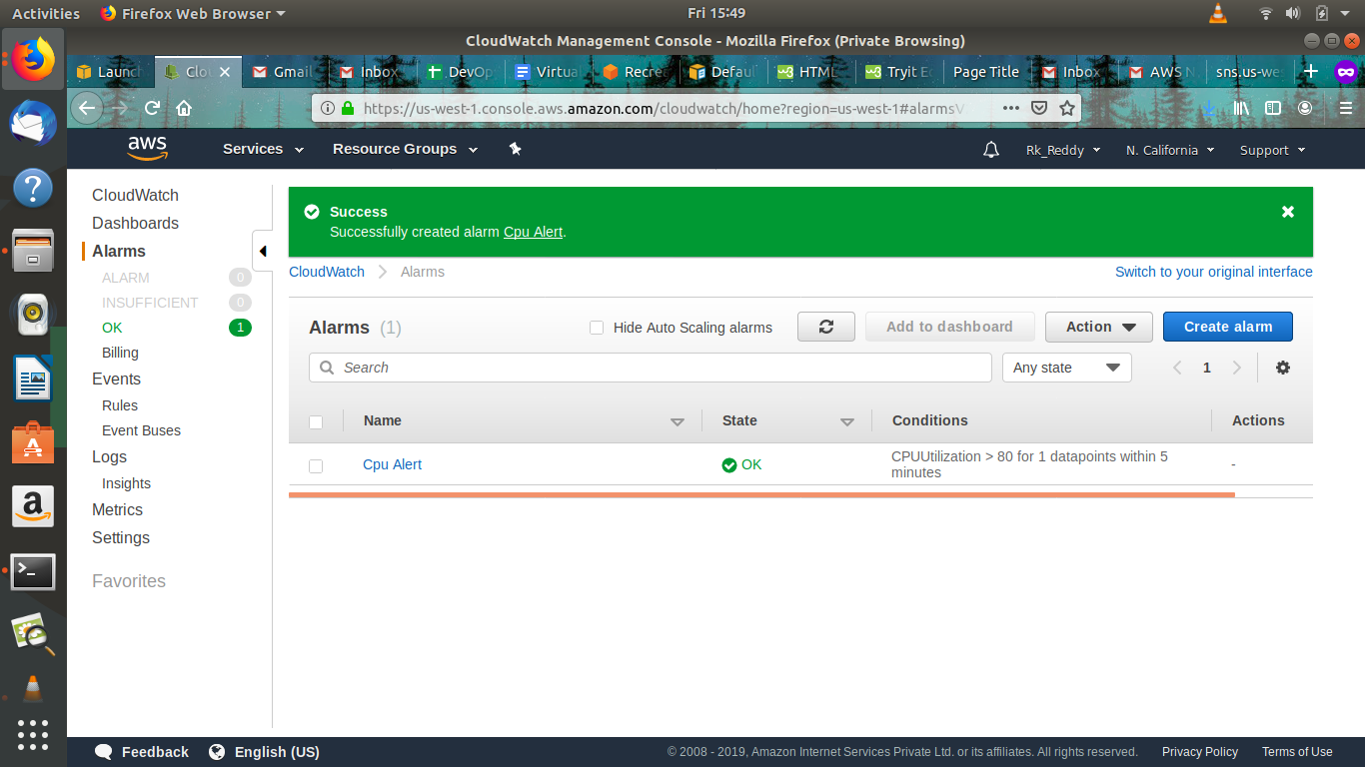

**3.Creating s3 Bucket and uploading files in s3 bucket.**

Amazon Simple Storage Service (Amazon S3) is storage for the Internet. You can use Amazon S3 to store and retrieve any amount of data at any time, from anywhere on the web. You can accomplish these tasks using the AWS Management Console, which is a simple and intuitive web interface

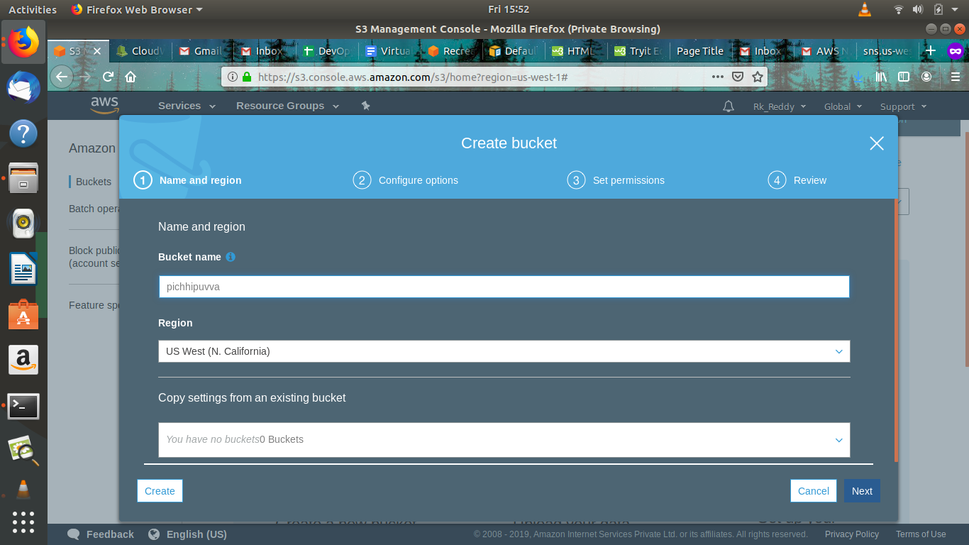  
  
  
  
  
  
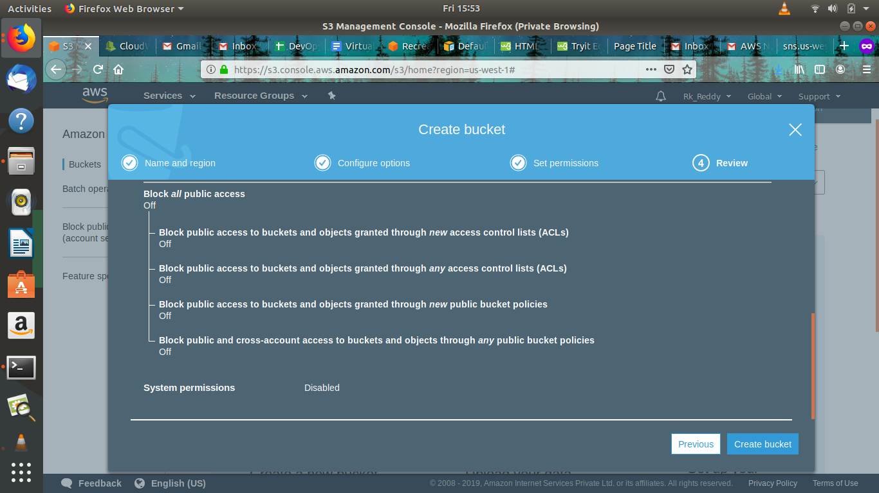  
  
  
  
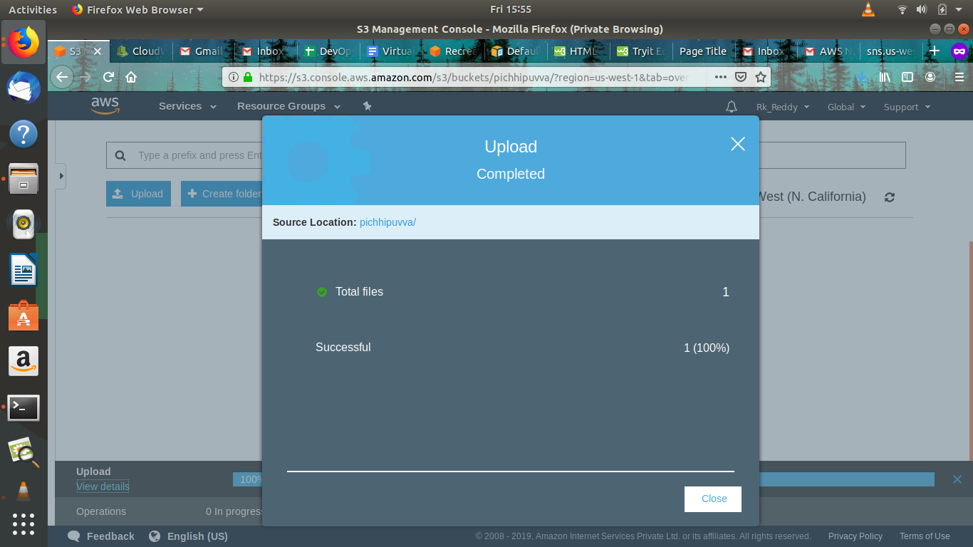  
  
  
  
  
  
  
  
  
  
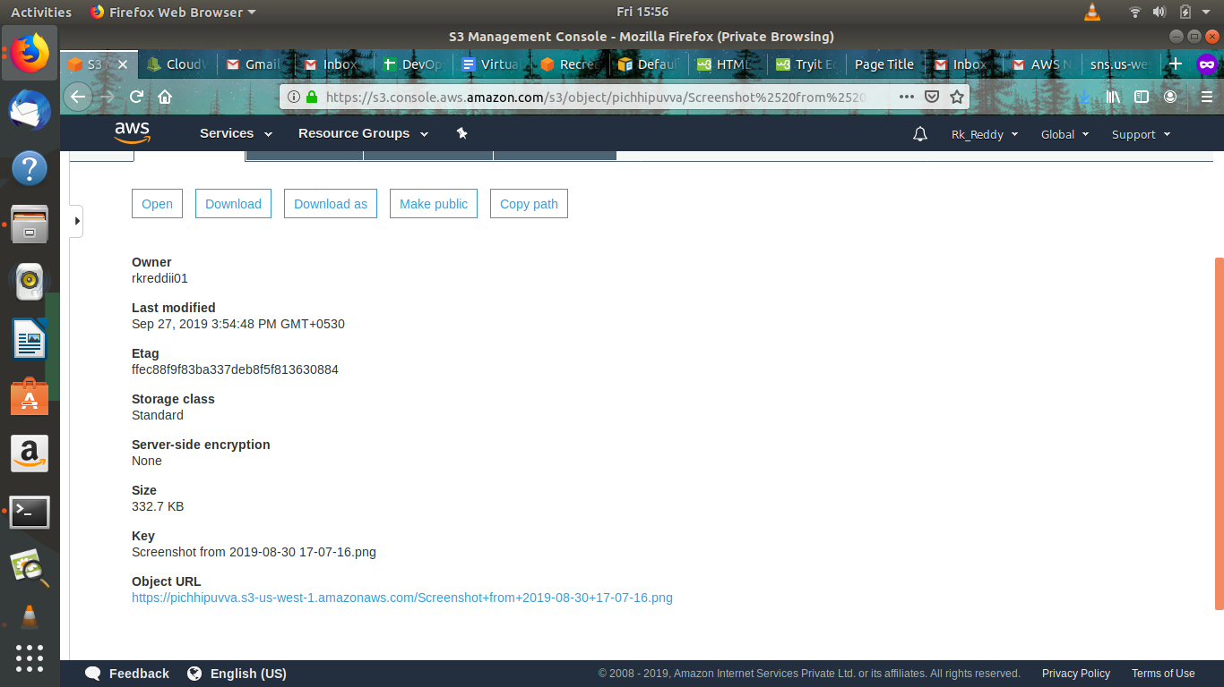

**4.IAM(Identity and Authentication management) User Creation**

AWS Identity and Access Management (IAM) is a web service that helps you securely control access to AWS resources. You use IAM to control who is authenticated (signed in) and authorized (has permissions) to use resources.

When you first create an AWS account, you begin with a single sign-in identity that has complete access to all AWS services and resources in the account. This identity is called the AWS account *root user* and is accessed by signing in with the email address and password that you used to create the account.

**Multi-factor authentication (MFA)**

You can add two-factor authentication to your account and to individual users for extra security. With MFA you or your users must provide not only a password or access key to work with your account, but also a code from a specially configured device.

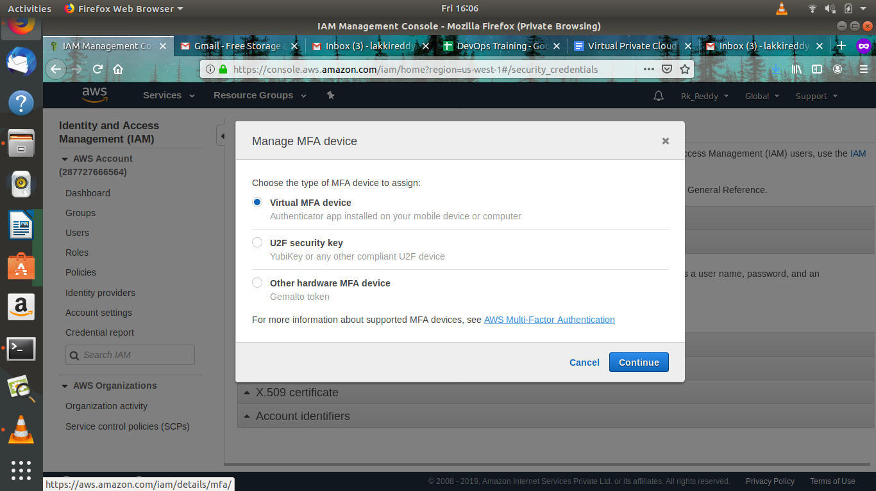  
  
  


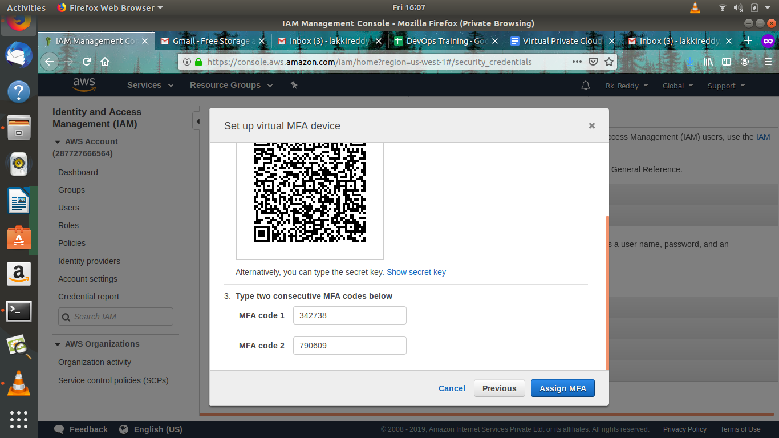  
  
  
  
  
  
  
  
  
  
  
  
  
  
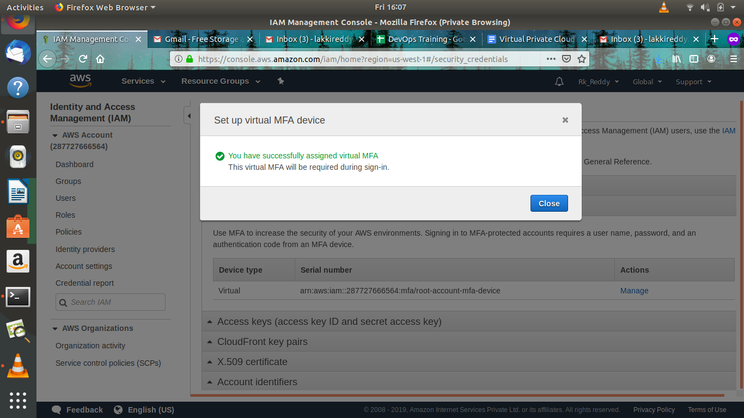  
  
  
  
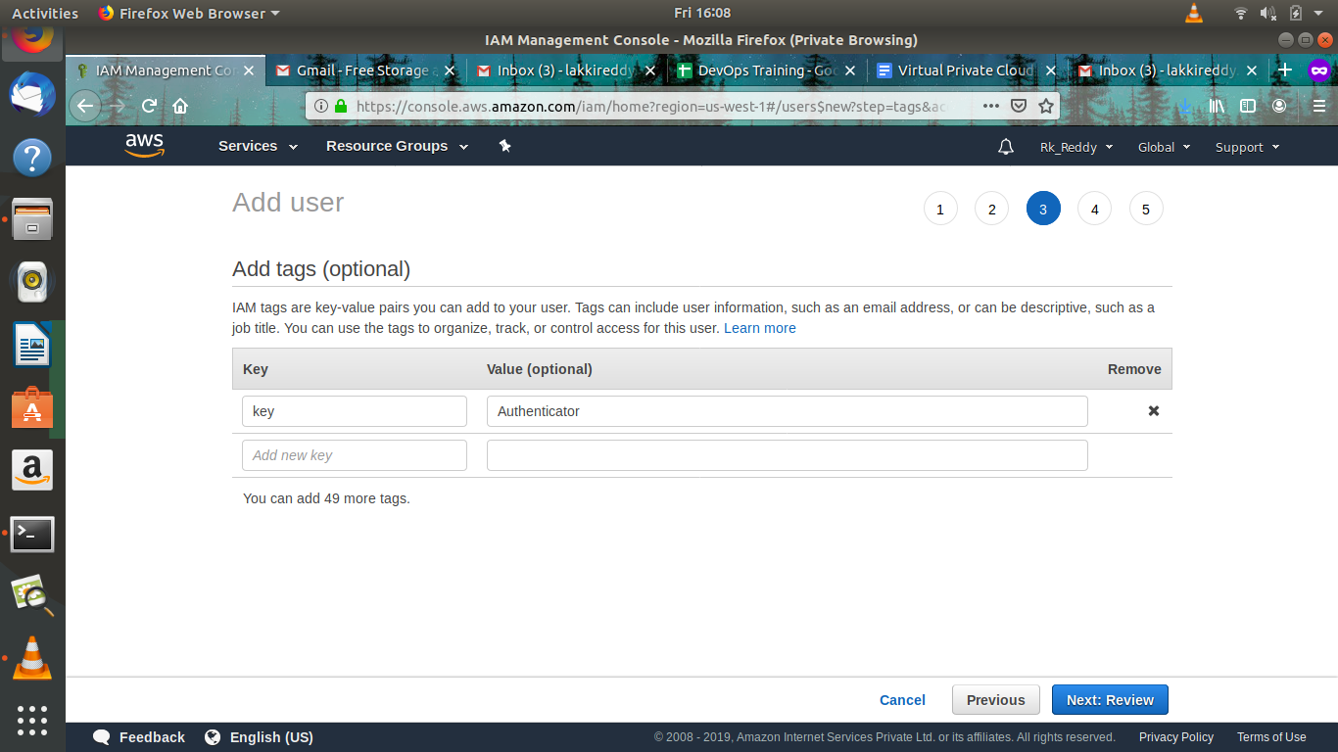  
  
  
  
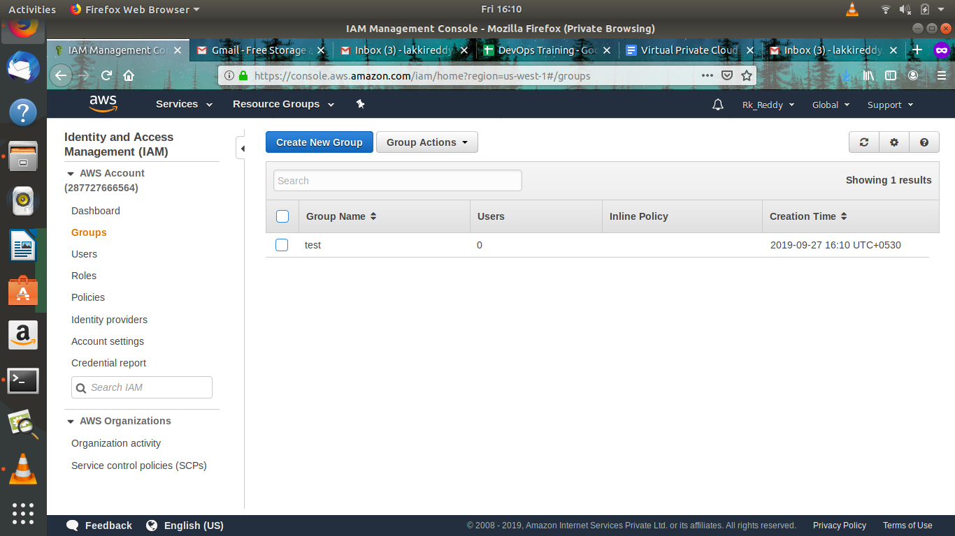  
  
  
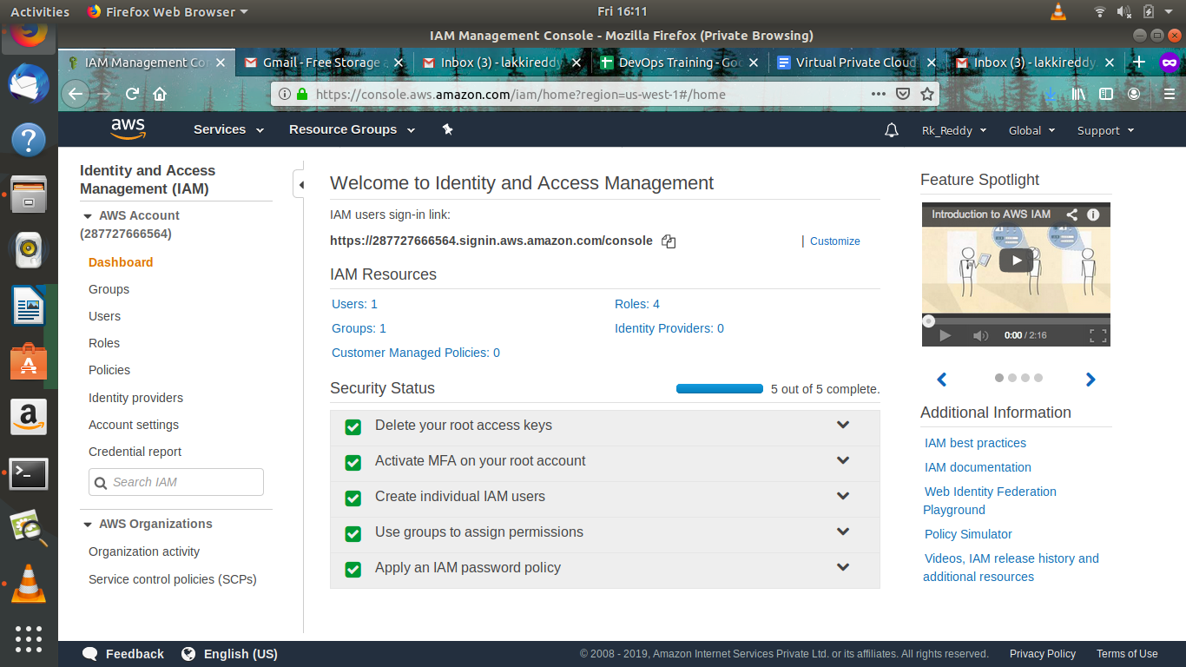

**5.AMI(Amazon Machine Image) Creation.**

# **Amazon Machine Images (AMI)**

An Amazon Machine Image (AMI) provides the information required to launch an instance. You must specify an AMI when you launch an instance. You can launch multiple instances from a single AMI when you need multiple instances with the same configuration. You can use different AMIs to launch instances when you need instances with different configurations.

An AMI includes the following:

* One or more EBS snapshots, or, for instance-store-backed AMIs, a template for the root volume of the instance (for example, an operating system, an application server,and applications).
* Launch permissions that control which AWS accounts can use the AMI to launch nstances.
* A block device mapping that specifies the volumes to attach to the instance when it's launched.

You can launch an instance from an existing AMI, customize the instance, and then save this updated configuration as a custom AMI. Instances launched from this new custom AMI include the customizations that you made when you created the AMI.

## 

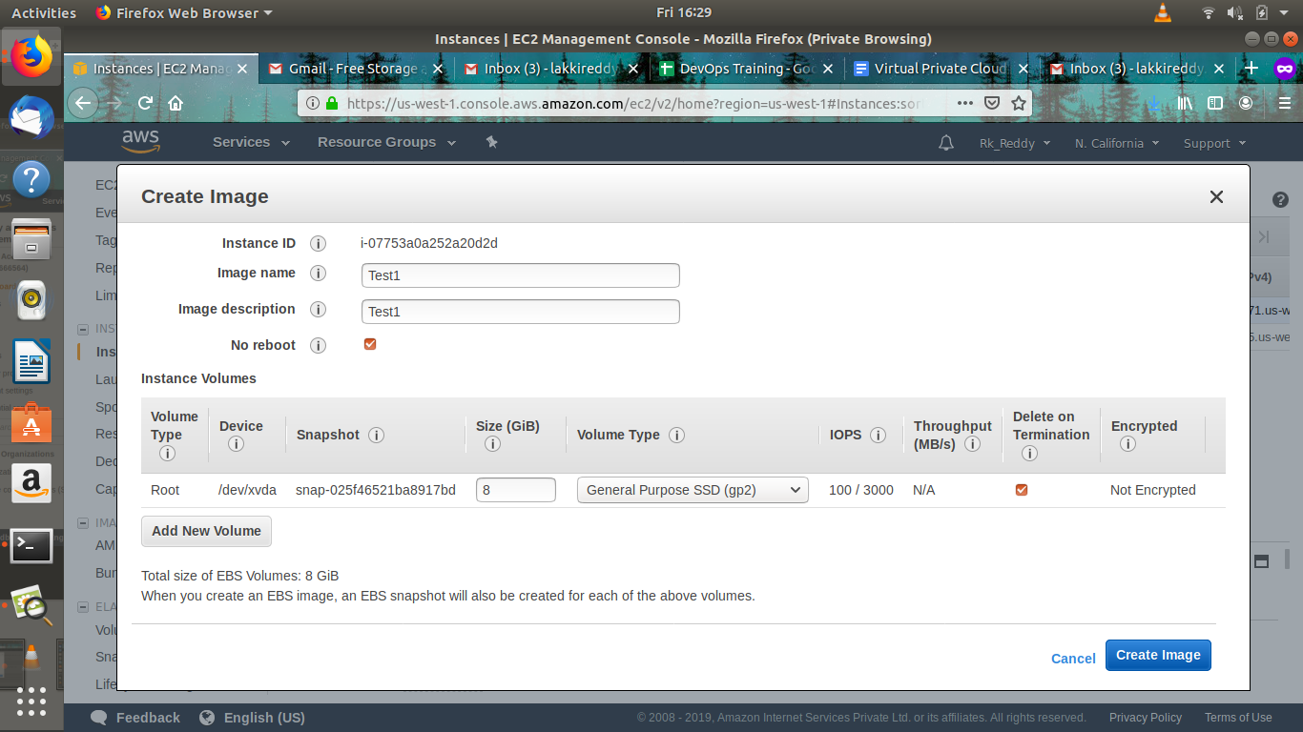

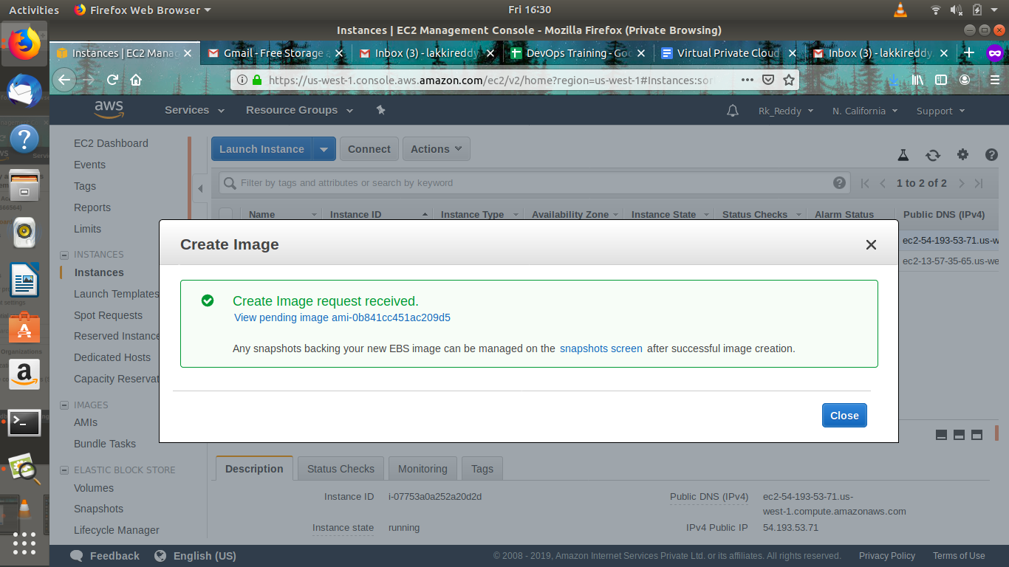  
  
  
  
  
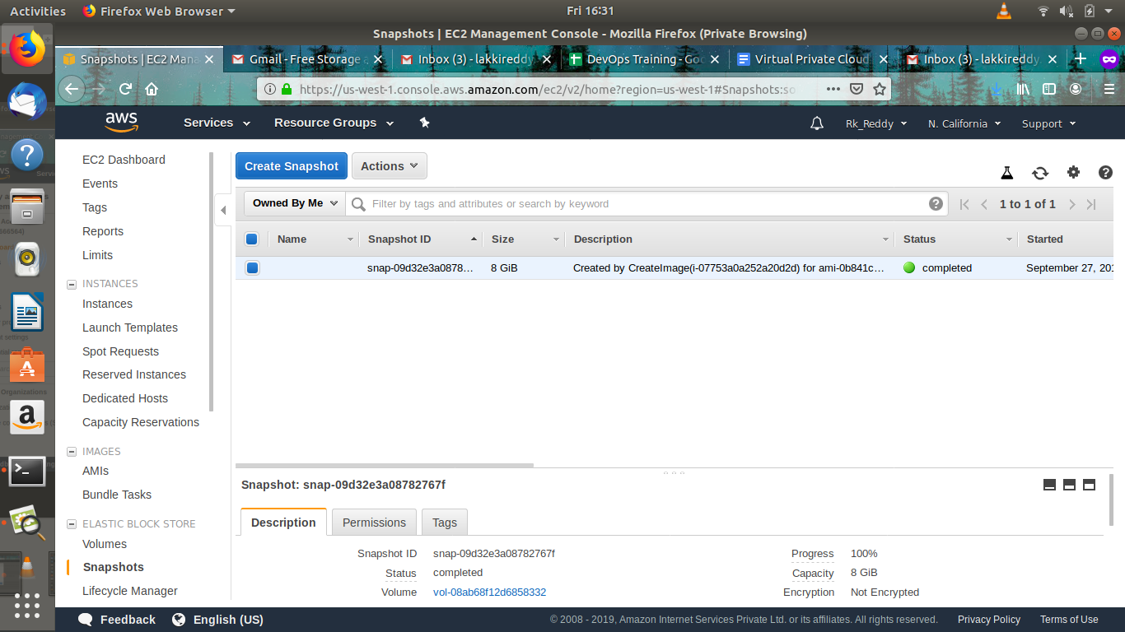  
  
  
  
  
  
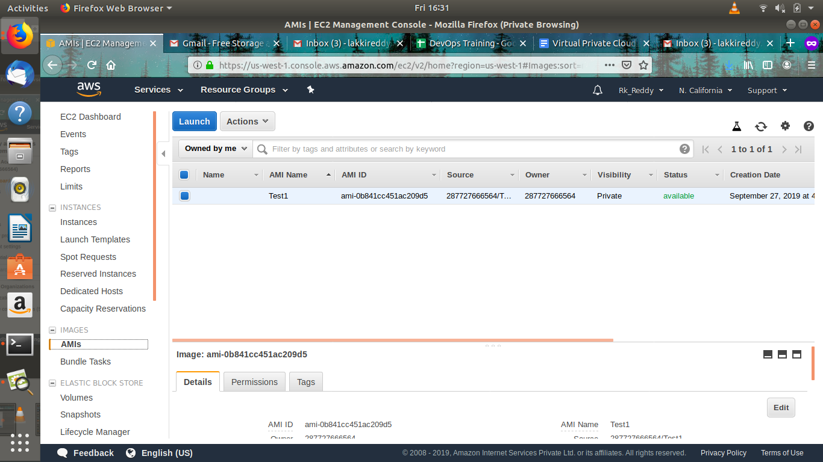

**6.Load Balancer Creation**

A load balancer serves as the single point of contact for clients. The load balancer distributes incoming application traffic across multiple targets, such as EC2 instances, in multiple Availability Zones. This increases the availability of your application. You add one or more listeners to your load balancer.

A listener checks for connection requests from clients, using the protocol and port that you configure. The rules that you define for a listener determine how the load balancer routes requests to its registered targets. Each rule consists of a priority, one or more actions, and one or more conditions. When the conditions for a rule are met, then its actions are performed. You must define a default rule for each listener, and you can optionally define additional rules.

Each target group routes requests to one or more registered targets, such as EC2 instances, using the protocol and port number that you specify. You can register a target with multiple target groups. You can configure health checks on a per target group basis. Health checks are performed on all targets registered to a target group that is specified in a listener rule for your load balancer.

* [Step 1: Select a Load Balancer Type](https://docs.aws.amazon.com/elasticloadbalancing/latest/application/application-load-balancer-getting-started.html#select-load-balancer-type)
* [Step 2: Configure Your Load Balancer and Listener](https://docs.aws.amazon.com/elasticloadbalancing/latest/application/application-load-balancer-getting-started.html#configure-load-balancer)
* [Step 3: Configure a Security Group for Your Load Balancer](https://docs.aws.amazon.com/elasticloadbalancing/latest/application/application-load-balancer-getting-started.html#configure-security-groups)
* [Step 4: Configure Your Target Group](https://docs.aws.amazon.com/elasticloadbalancing/latest/application/application-load-balancer-getting-started.html#configure-target-group)
* [Step 5: Register Targets with Your Target Group](https://docs.aws.amazon.com/elasticloadbalancing/latest/application/application-load-balancer-getting-started.html#add-targets)
* [Step 6: Create and Test Your Load Balancer](https://docs.aws.amazon.com/elasticloadbalancing/latest/application/application-load-balancer-getting-started.html#test-load-balancer)
* [Step 7: Delete Your Load Balancer (Optional)](https://docs.aws.amazon.com/elasticloadbalancing/latest/application/application-load-balancer-getting-started.html#delete-load-balancer)

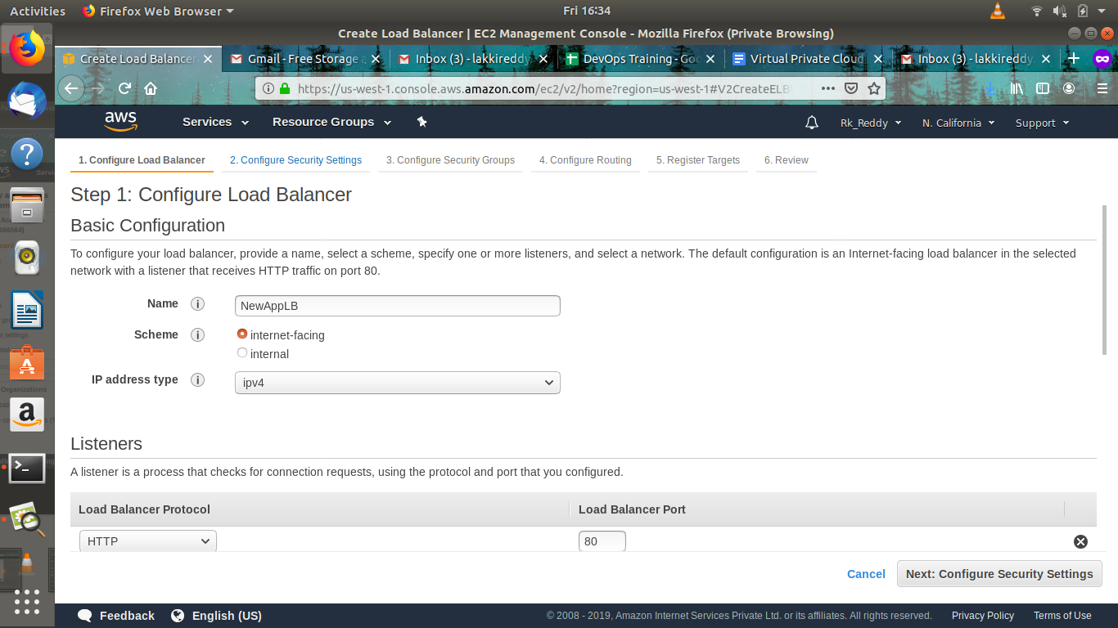  
  
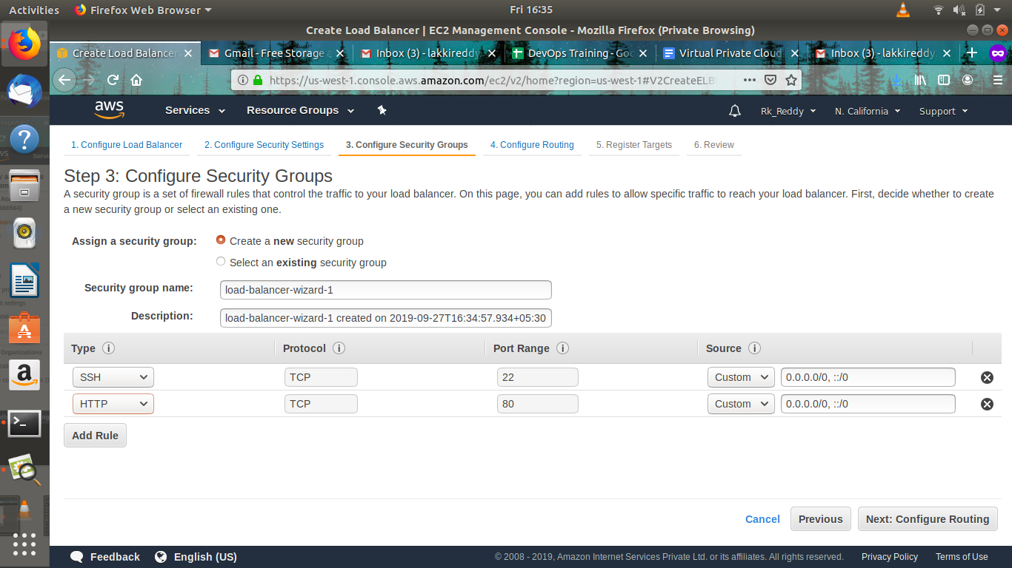  
  
  
  
  
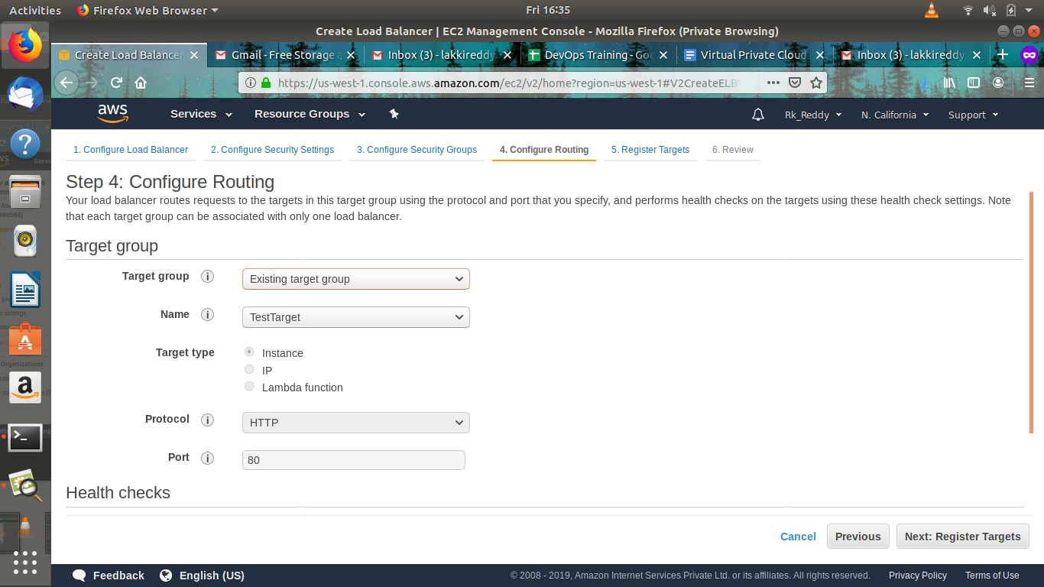  
  
  
  
  
  
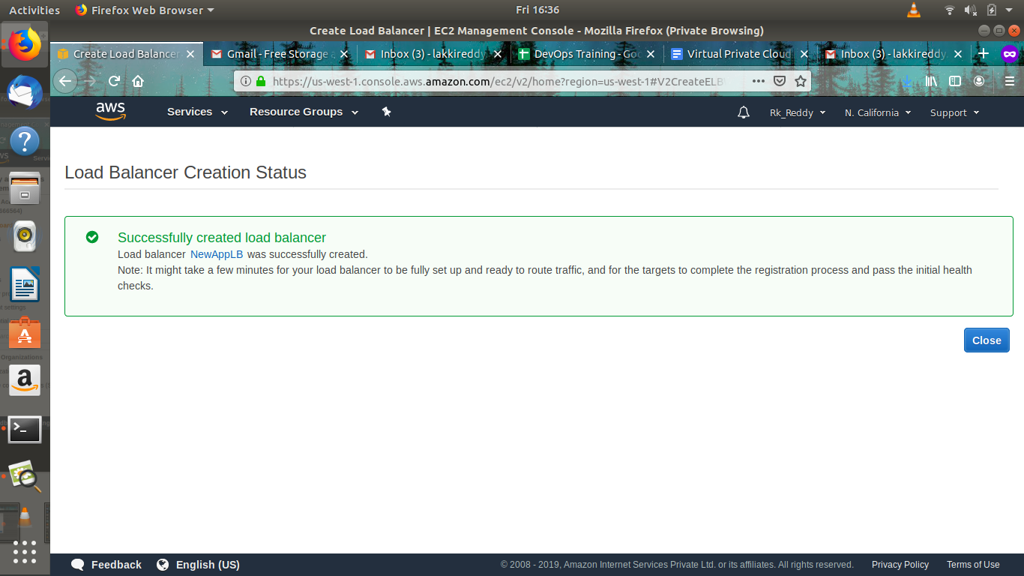  
  
  
  
  
  
  
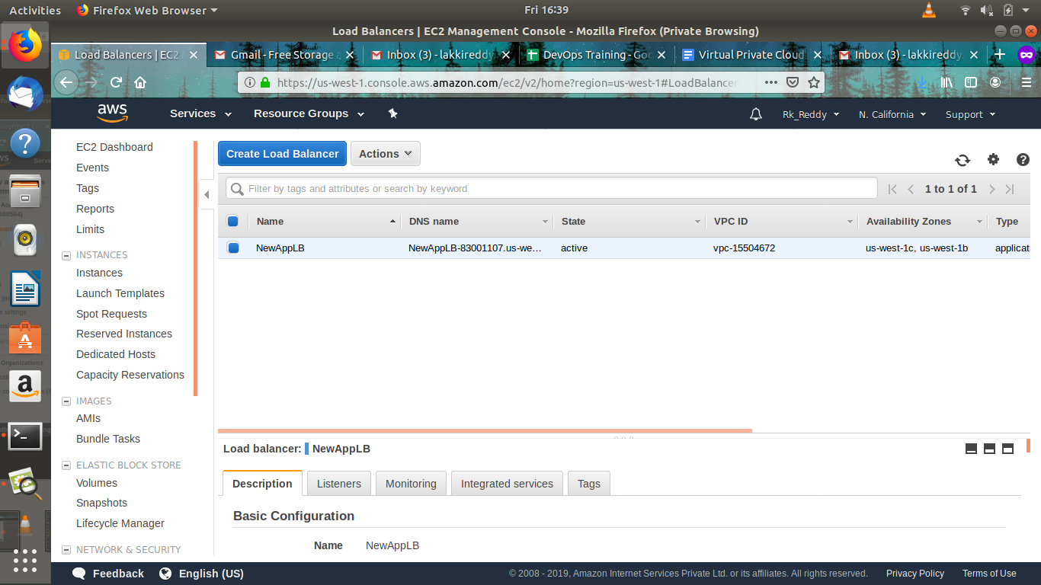

After, Creation of load balancer we can use the Dns name of loadbalancer to visit the two different paths and see the results.

The load balancer follows round robin to load the balance. It will send one request to one server and another request to another server.

**7.AutoScaling**

Amazon EC2 Auto Scaling helps you ensure that you have the correct number of Amazon EC2 instances available to handle the load for your application. You create collections of EC2 instances, called Auto Scaling groups. You can specify the minimum number of instances in each Auto Scaling group, and Amazon EC2 Auto Scaling ensures that your group never goes below this size. You can specify the maximum number of instances in each Auto Scaling group, and Amazon EC2 Auto Scaling ensures that your group never goes above this size. If you specify the desired capacity, either when you create the group or at any time thereafter, Amazon EC2 Auto Scaling ensures that your group has this many instances. If you specify scaling policies, then Amazon EC2 Auto Scaling can launch or terminate instances as demand on your application increases or decreases.

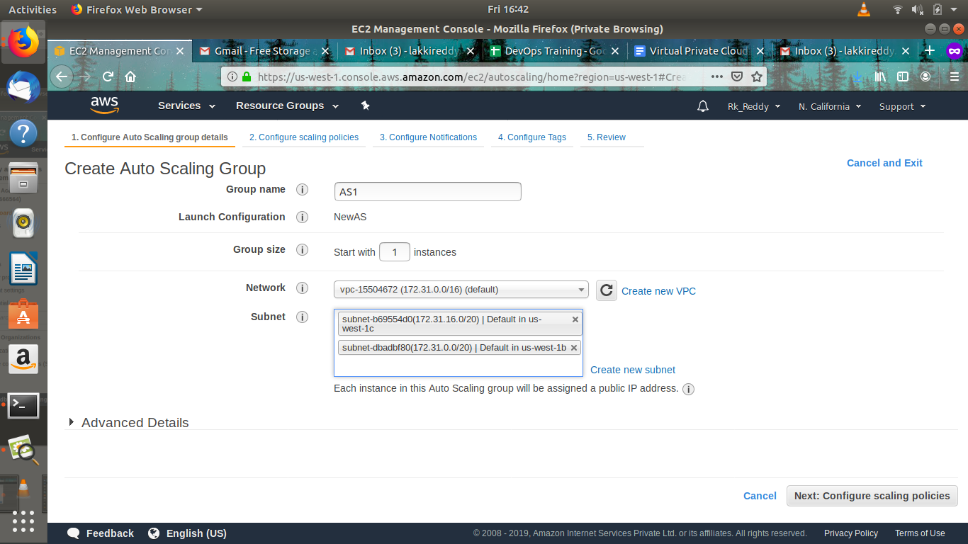

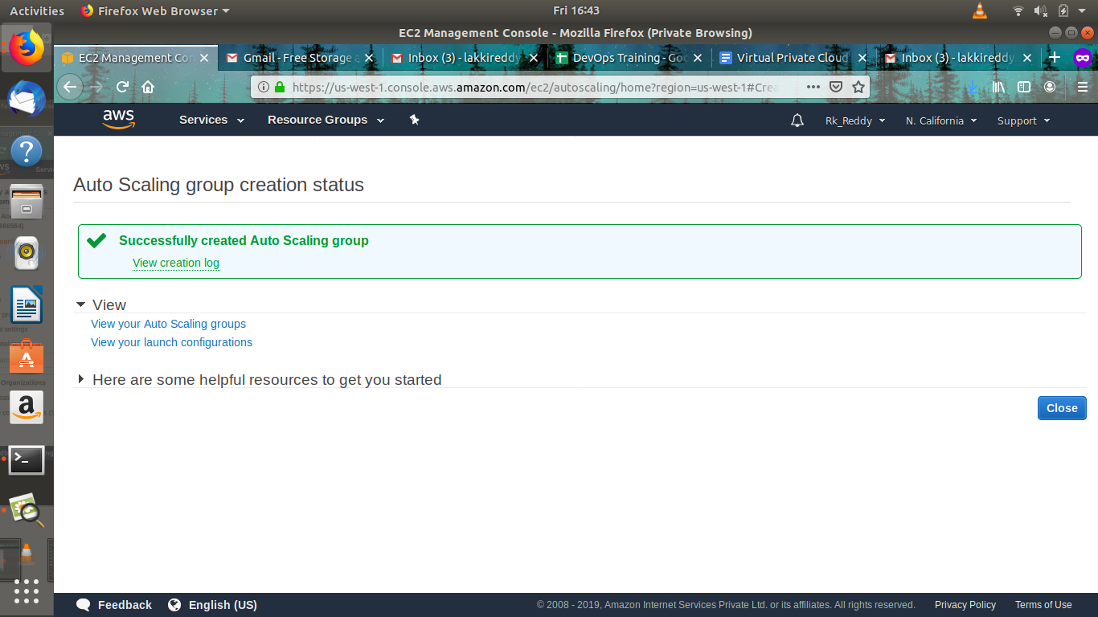

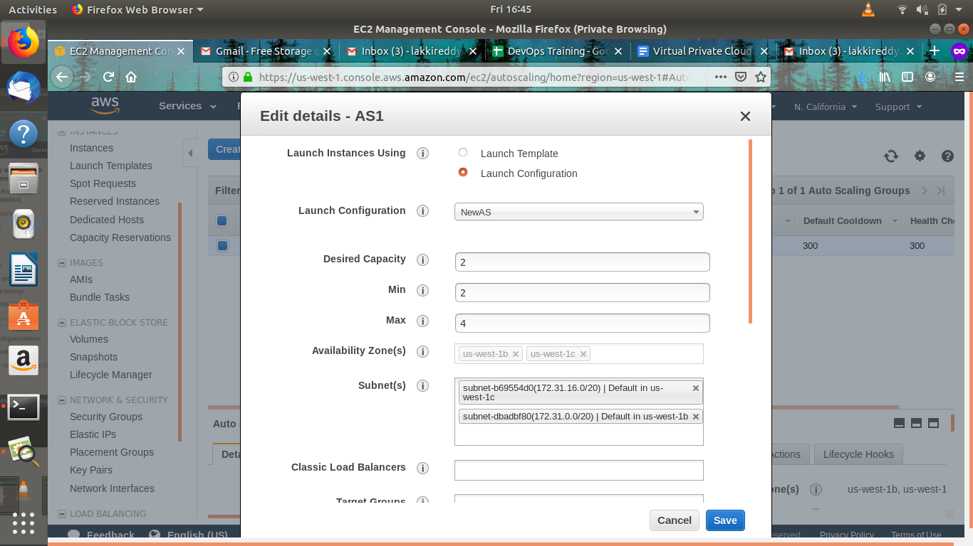

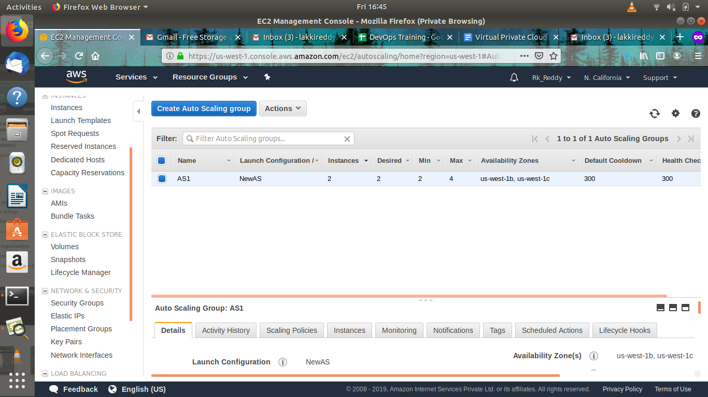  
  
  
**8.WebServers**

Yum install nginx

server {

listen 80;

server_name 54.193.53.71;

root /var/www/html/NaMod;

index index.html;

}

Here, I created a file named /var/www/html/namod.html

If i search with ip or /namod the below web page will be open.

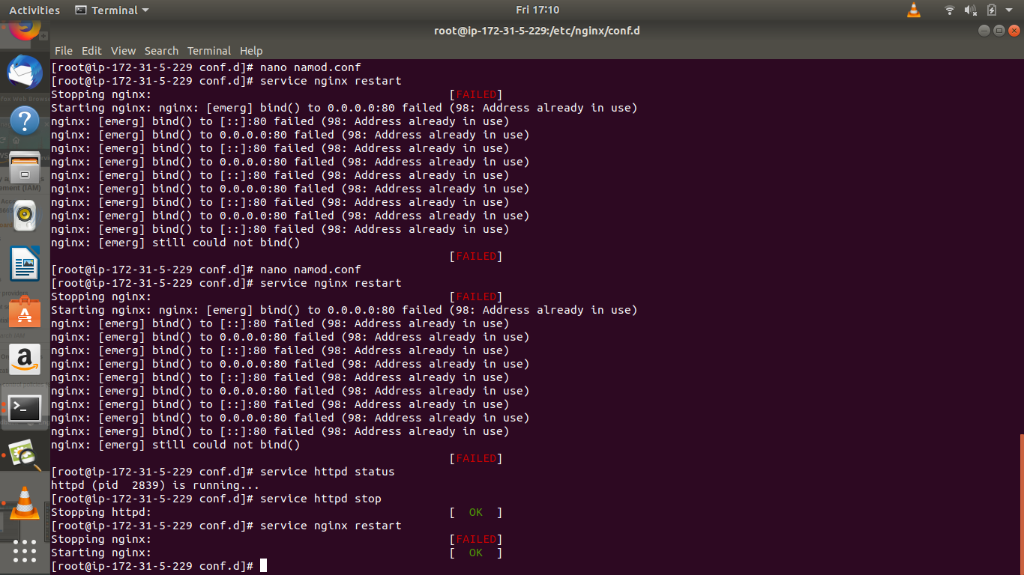  
  
  
  
  
  
  
  
  
  
  
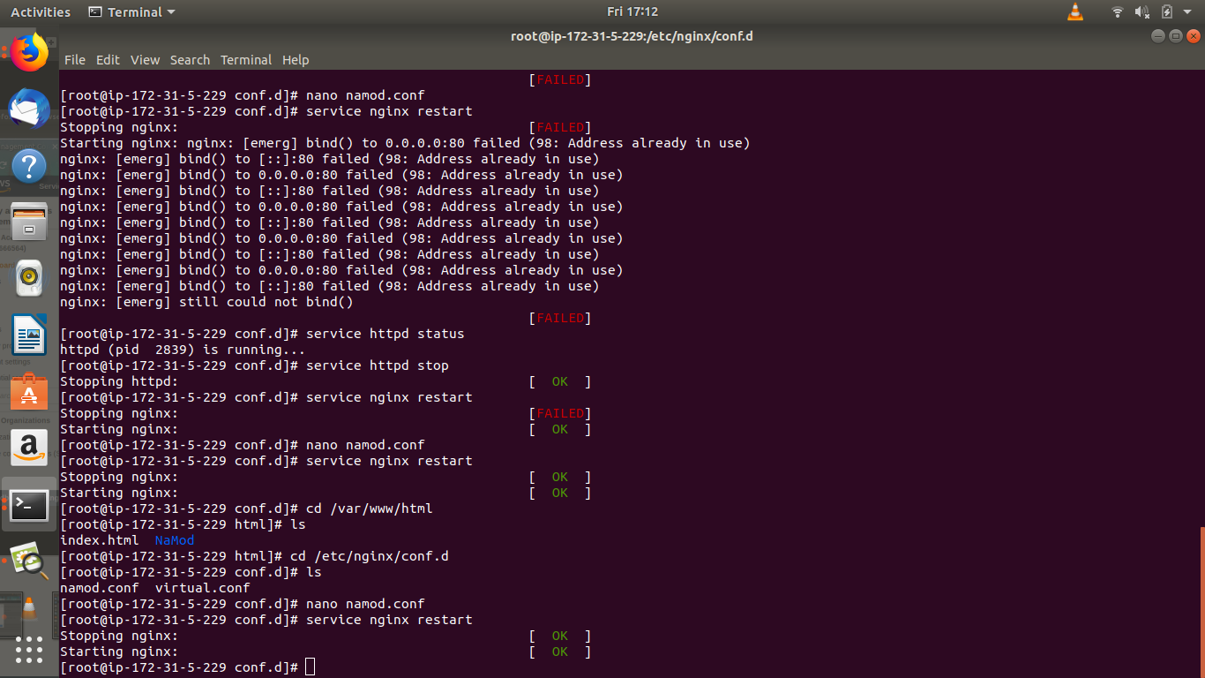  
  
  
  
  
  
  
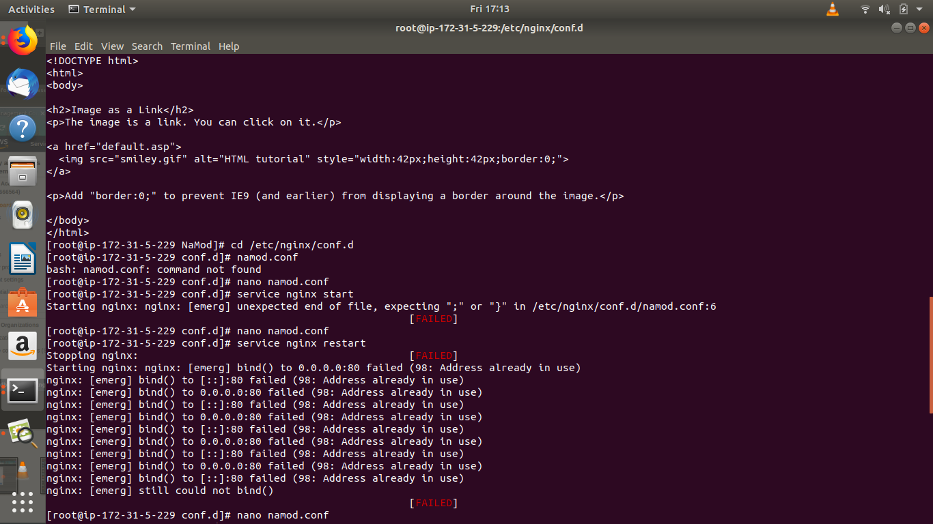  
  
  
  
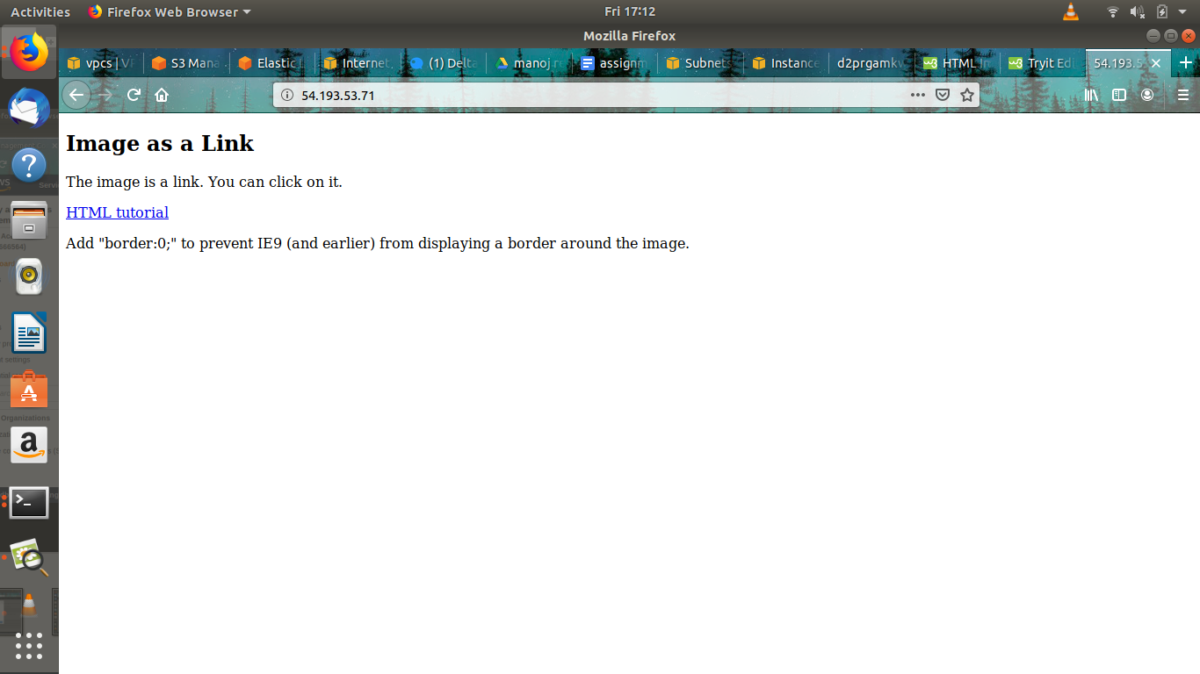

**9.Cloud Formation**

AWS CloudFormation is a service that helps you model and set up your Amazon Web Services resources so that you can spend less time managing those resources and more time focusing on your applications that run in AWS. Meaning you write a template in JSON and use it to launch resources. This is very useful if you have to launch the same type of infrastructure multiple times and simplifies provisioning and management on AWS. You can create templates for the service or application architectures you want and have AWS CloudFormation use those templates for quick and reliable provisioning of the services or applications (called “stacks”). You can also easily update or replicate the stacks as needed.

[**Format Version (optional)**](http://docs.aws.amazon.com/AWSCloudFormation/latest/UserGuide/format-version-structure.html)Specifies the AWS CloudFormation template version that the template conforms to

[**Description (optional)**](http://docs.aws.amazon.com/AWSCloudFormation/latest/UserGuide/template-description-structure.html)A text string that describes the template.

[**Metadata (optional)**](http://docs.aws.amazon.com/AWSCloudFormation/latest/UserGuide/metadata-section-structure.html) YAML objects that provide additional information about the template.

[**Parameters (optional)**](http://docs.aws.amazon.com/AWSCloudFormation/latest/UserGuide/parameters-section-structure.html)Specifies values that you can pass in to your template at runtime.

[**Mappings (optional)**](http://docs.aws.amazon.com/AWSCloudFormation/latest/UserGuide/mappings-section-structure.html)A mapping of keys and associated values that you can use to specify conditional parameter values, similar to a lookup table.

[**Conditions (optional)**](http://docs.aws.amazon.com/AWSCloudFormation/latest/UserGuide/conditions-section-structure.html)Defines conditions that control whether certain resources are created or whether certain resource properties are assigned a value during stack creation or update.

[**Outputs (optional)**](http://docs.aws.amazon.com/AWSCloudFormation/latest/UserGuide/outputs-section-structure.html)Describes the values that are returned whenever you view your stack’s properties.

[**Resources (required)**](http://docs.aws.amazon.com/AWSCloudFormation/latest/UserGuide/resources-section-structure.html)Specifies the stack resources and their properties, such as an Amazon Elastic Compute Cloud instance or an Amazon Simple Storage Service bucket

**Creation of Cloud Template:-**

Here, Below is script for creation of template

*AWSTemplateFormatVersion: 2010-09-09*

*Description: >-*

*AWS CloudFormation Sample Template EC2InstanceWithSecurityGroupSample: Create*

*an Amazon EC2 instance running the Amazon Linux AMI. The AMI is chosen based*

*on the region in which the stack is run. This example creates an EC2 security*

*group for the instance to give you SSH access.*

*Parameters:*

*KeyName:*

*Description: Name of an existing EC2 KeyPair to enable SSH access to the instance*

*Type: 'AWS::EC2::KeyPair::KeyName'*

*ConstraintDescription: must be the name of an existing EC2 KeyPair.*

*InstanceType:*

*Description: WebServer EC2 instance type*

*Type: String*

*Default: t2.micro*

*ConstraintDescription: must be a valid EC2 instance type.*

*AllowedValues:*

*- t2.micro*

*- t2.large*

*- t2.medium*

*SSHLocation:*

*Description: The IP address range that can be used to SSH to the EC2 instances*

*Type: String*

*MinLength: '9'*

*MaxLength: '18'*

*Default: 0.0.0.0/0*

*AllowedPattern: '(\d{1,3})\.(\d{1,3})\.(\d{1,3})\.(\d{1,3})/(\d{1,2})'*

*ConstraintDescription: must be a valid IP CIDR range of the form x.x.x.x/x.*

*VPCIdName:*

*Description: Select the VPICId name*

*Type: 'AWS::EC2::VPC::Id'*

*SubnetID:*

*Description: SubnetID*

*Type: 'AWS::EC2::Subnet::Id'*

*Mappings:*

*RegionMap:*

*us-east-2:*

*AMI : ami-0c64dd618a49aeee8*

*us-east-2:*

*AMI : ami-00c03f7f7f2ec15c3*

*ap-northeast-1:*

*AMI : ami-0c64dd618a49aeee8*

*ap-northeast-1:*

*AMI : ami-00c03f7f7f2ec15c3*

*Resources:*

*EC2Instance:*

*Type: 'AWS::EC2::Instance'*

*Properties:*

*InstanceType: !Ref InstanceType*

*SecurityGroups:*

*- !Ref InstanceSecurityGroup*

*KeyName: !Ref KeyName*

*ImageId: !FindInMap*

*- RegionMap*

*- !Ref AWS::Region*

*- AMI*

*UserData:*

*Fn::Base64:*

*!Sub |*

*#!/bin/bash -xe*

*yum install -y git*

*yum install -y httpd*

*cd /var/www/html*

*gitclone:*[*https://gitlab.com/Rk_Reddy/testproject*](https://gitlab.com/Rk_Reddy/testproject)*.git*

*cd testproject*

*mkdir local*

*cd local*

*touch rk.html*

*echo "This is a sub folder file" >> rk.html*

*cd /etc/httpd/conf.d*

*touch index.conf*

*echo "<VirtualHost *:80>*

*ServerName*

*ServerAdmin webmaster@localhost*

*DocumentRoot /var/www/html/testproject*

*<Location /sub>*

*DirectoryIndex rk.html*

*</Location>*

*</VirtualHost> " >> index.conf*

*InstanceSecurityGroup:*

*Type: 'AWS::EC2::SecurityGroup'*

*Properties:*

*GroupDescription: Enable SSH access via port 22*

*SecurityGroupIngress:*

*- IpProtocol: tcp*

*FromPort: '22'*

*ToPort: '22'*

*CidrIp: 0.0.0.0/0*

*- IpProtocol: tcp*

*FromPort: '80'*

*ToPort: '80'*

*CidrIp: 0.0.0.0/0*

*- IpProtocol: tcp*

*FromPort: '443'*

*ToPort: '443'*

*CidrIp: 0.0.0.0/0*

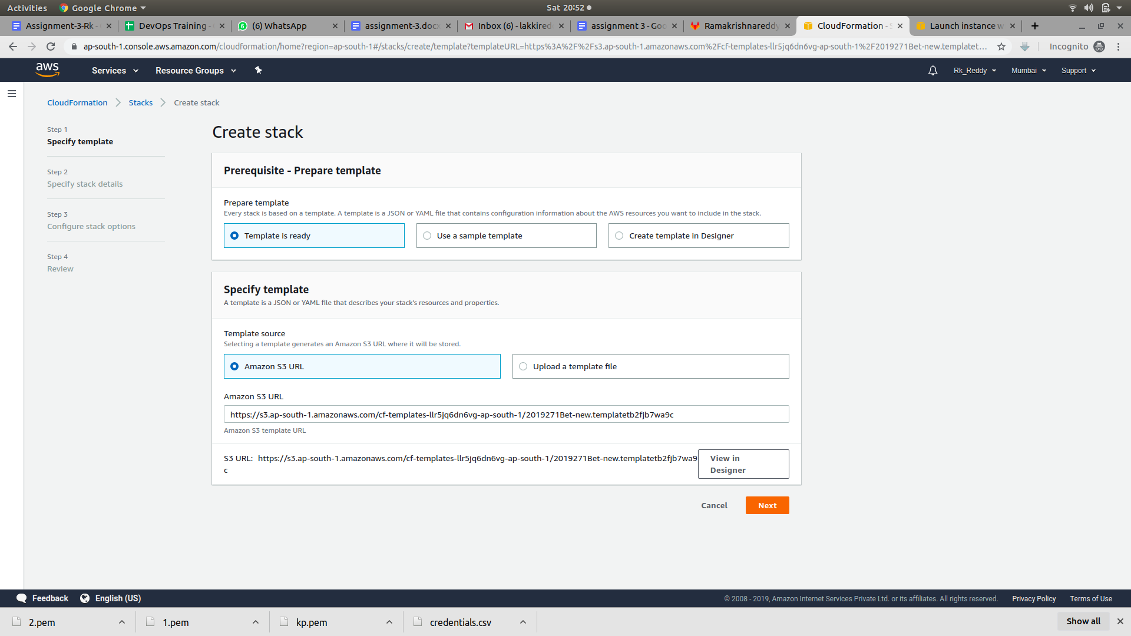

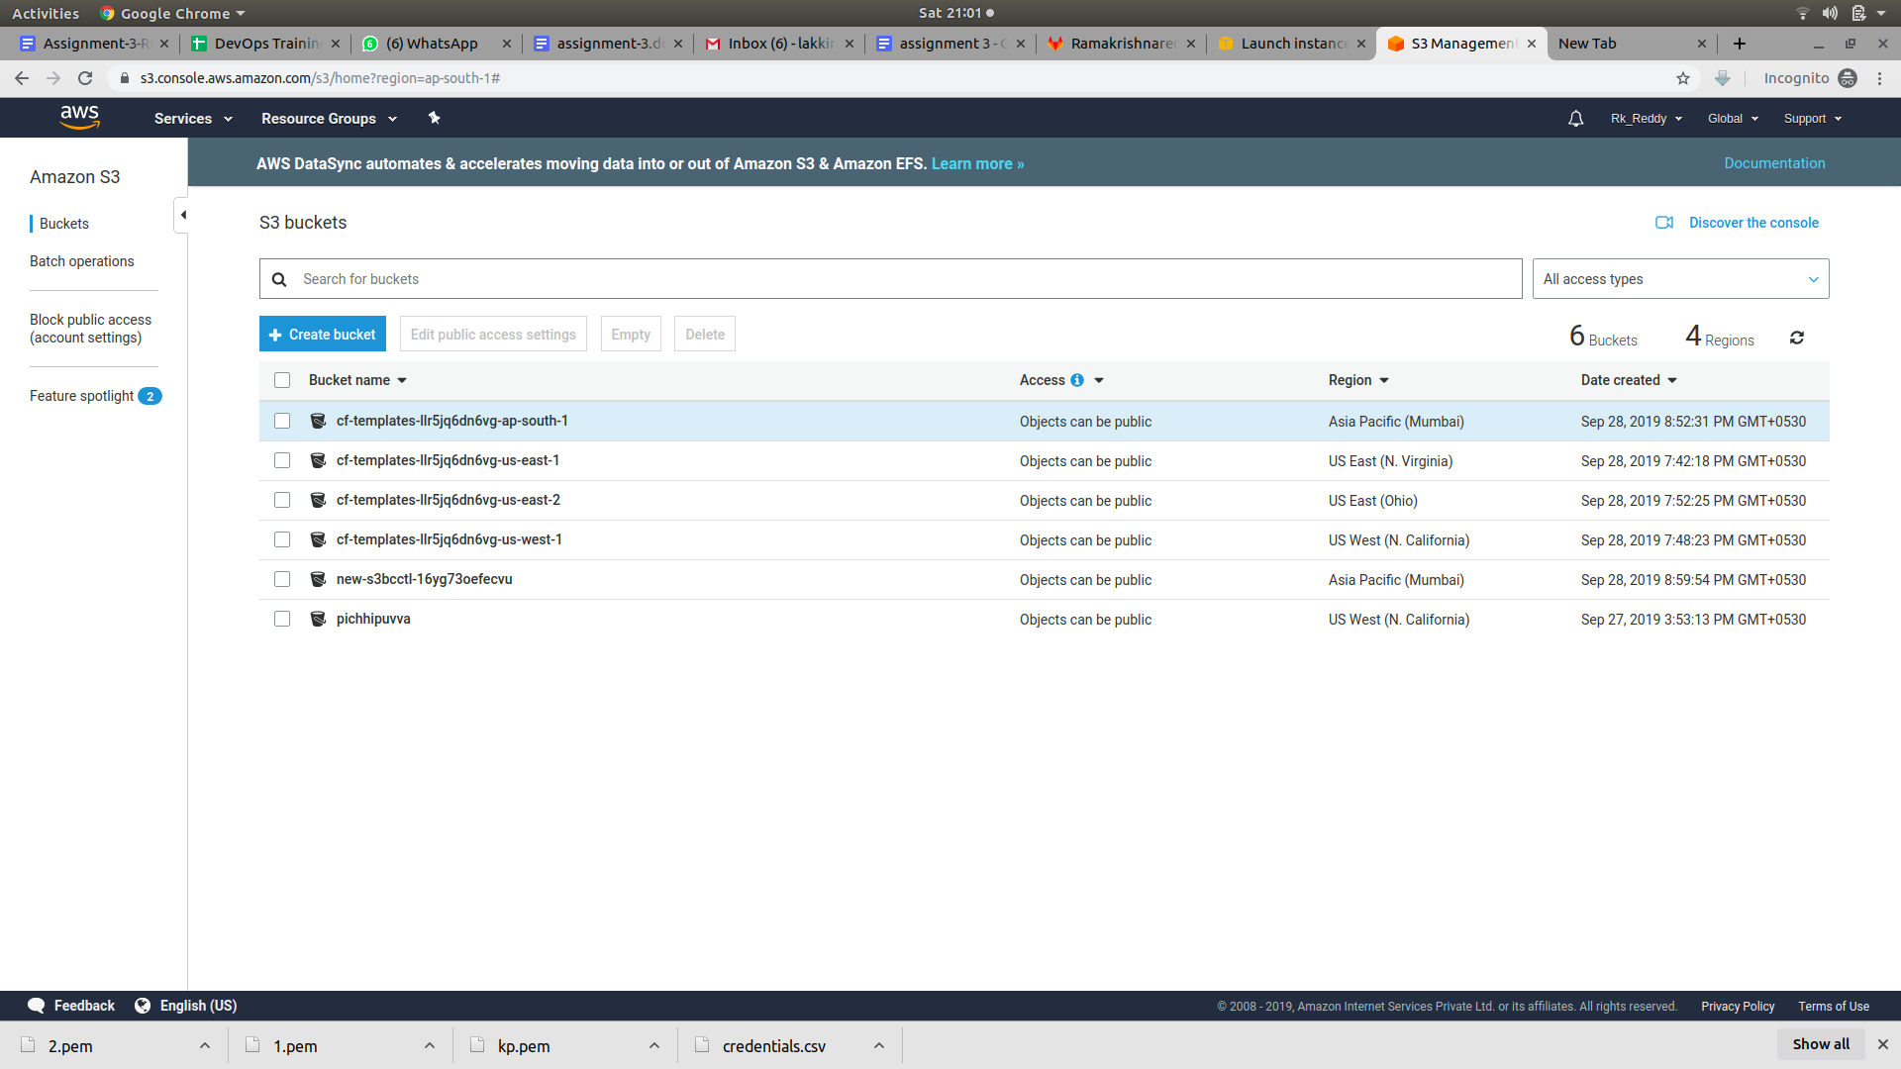

***Virtual Private Cloud***

Amazon Virtual Private Cloud (Amazon VPC) enables you to launch AWS resources into a virtual network that you've defined. This virtual network closely resembles a traditional network that you'd operate in your own data center, with the benefits of using the scalable infrastructure of AWS.

A virtual private cloud (VPC) is a virtual network dedicated to your AWS account. It is logically isolated from other virtual networks in the AWS Cloud. You can launch your AWS resources, such as Amazon EC2 instances, into your VPC. You can specify an IP address range for the VPC, add subnets, associate security groups, and configure route tables.

A subnet is a range of IP addresses in your VPC. You can launch AWS resources into a specified subnet. Use a public subnet for resources that must be connected to the internet, and a private subnet for resources that won't be connected to the internet

## 

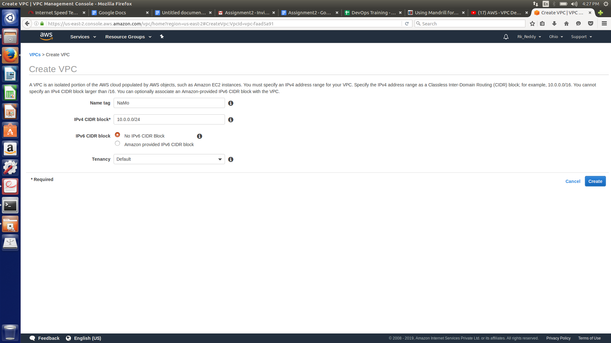

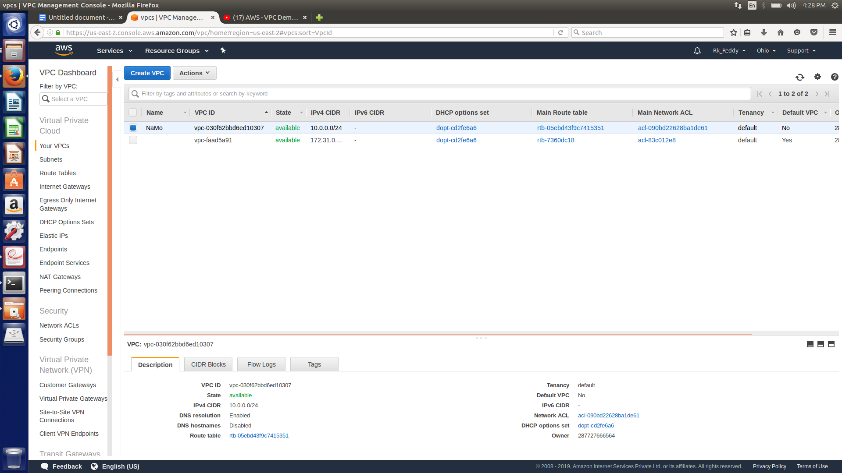

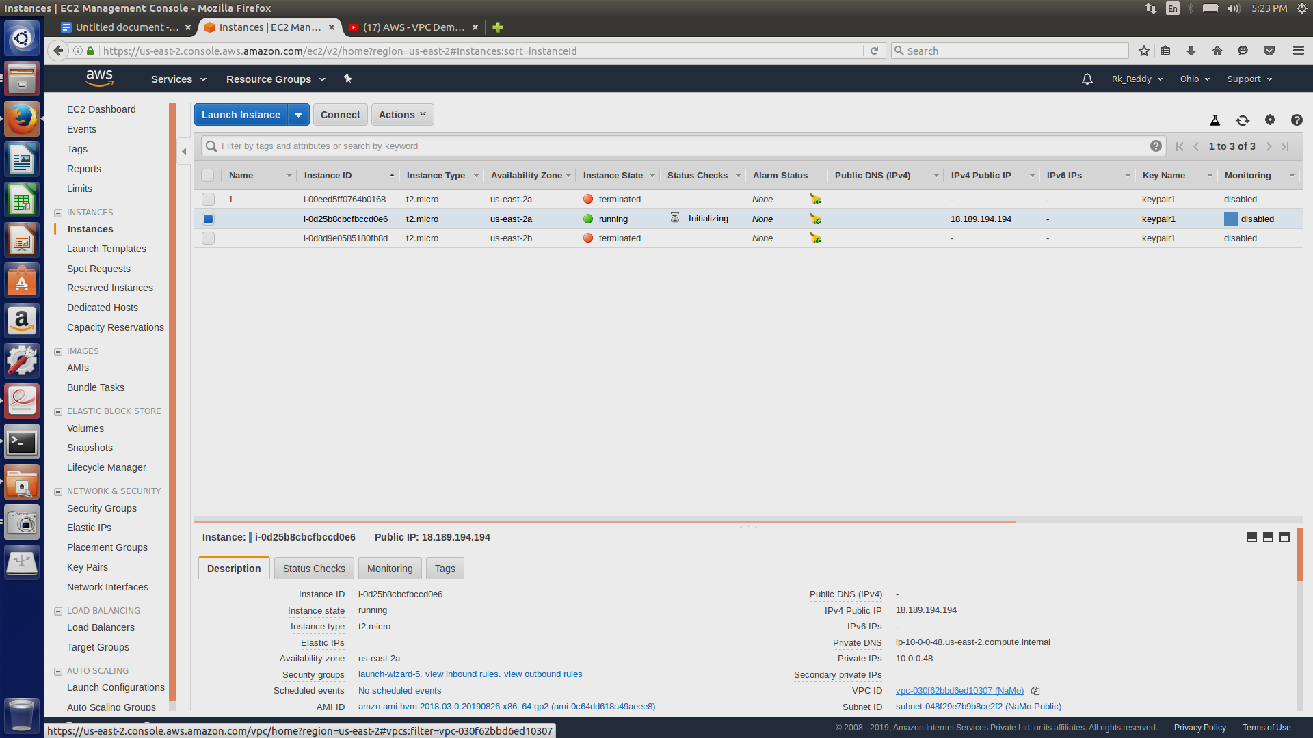

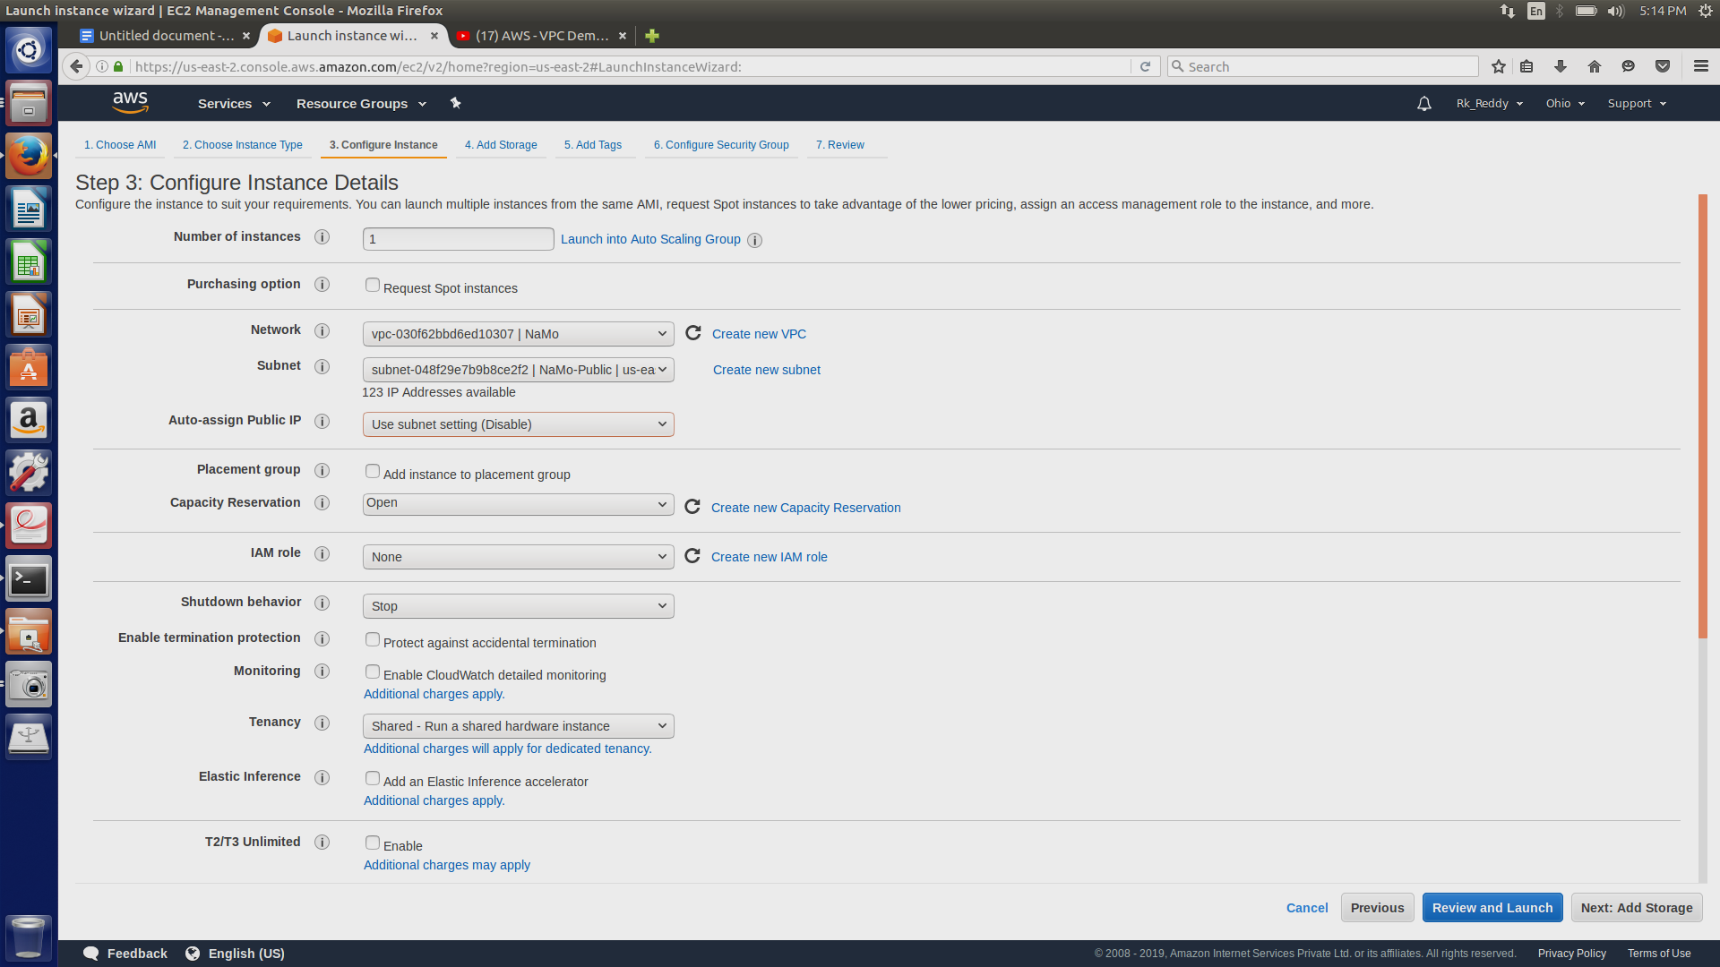

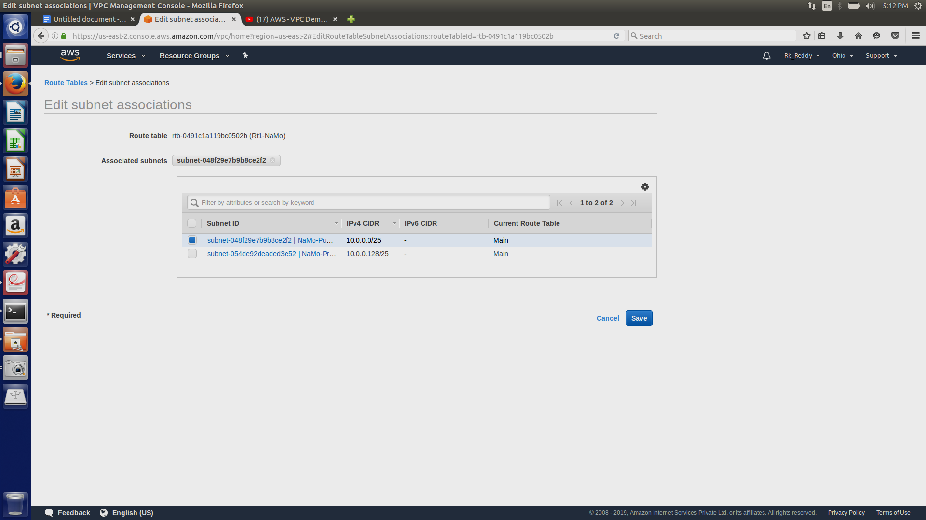

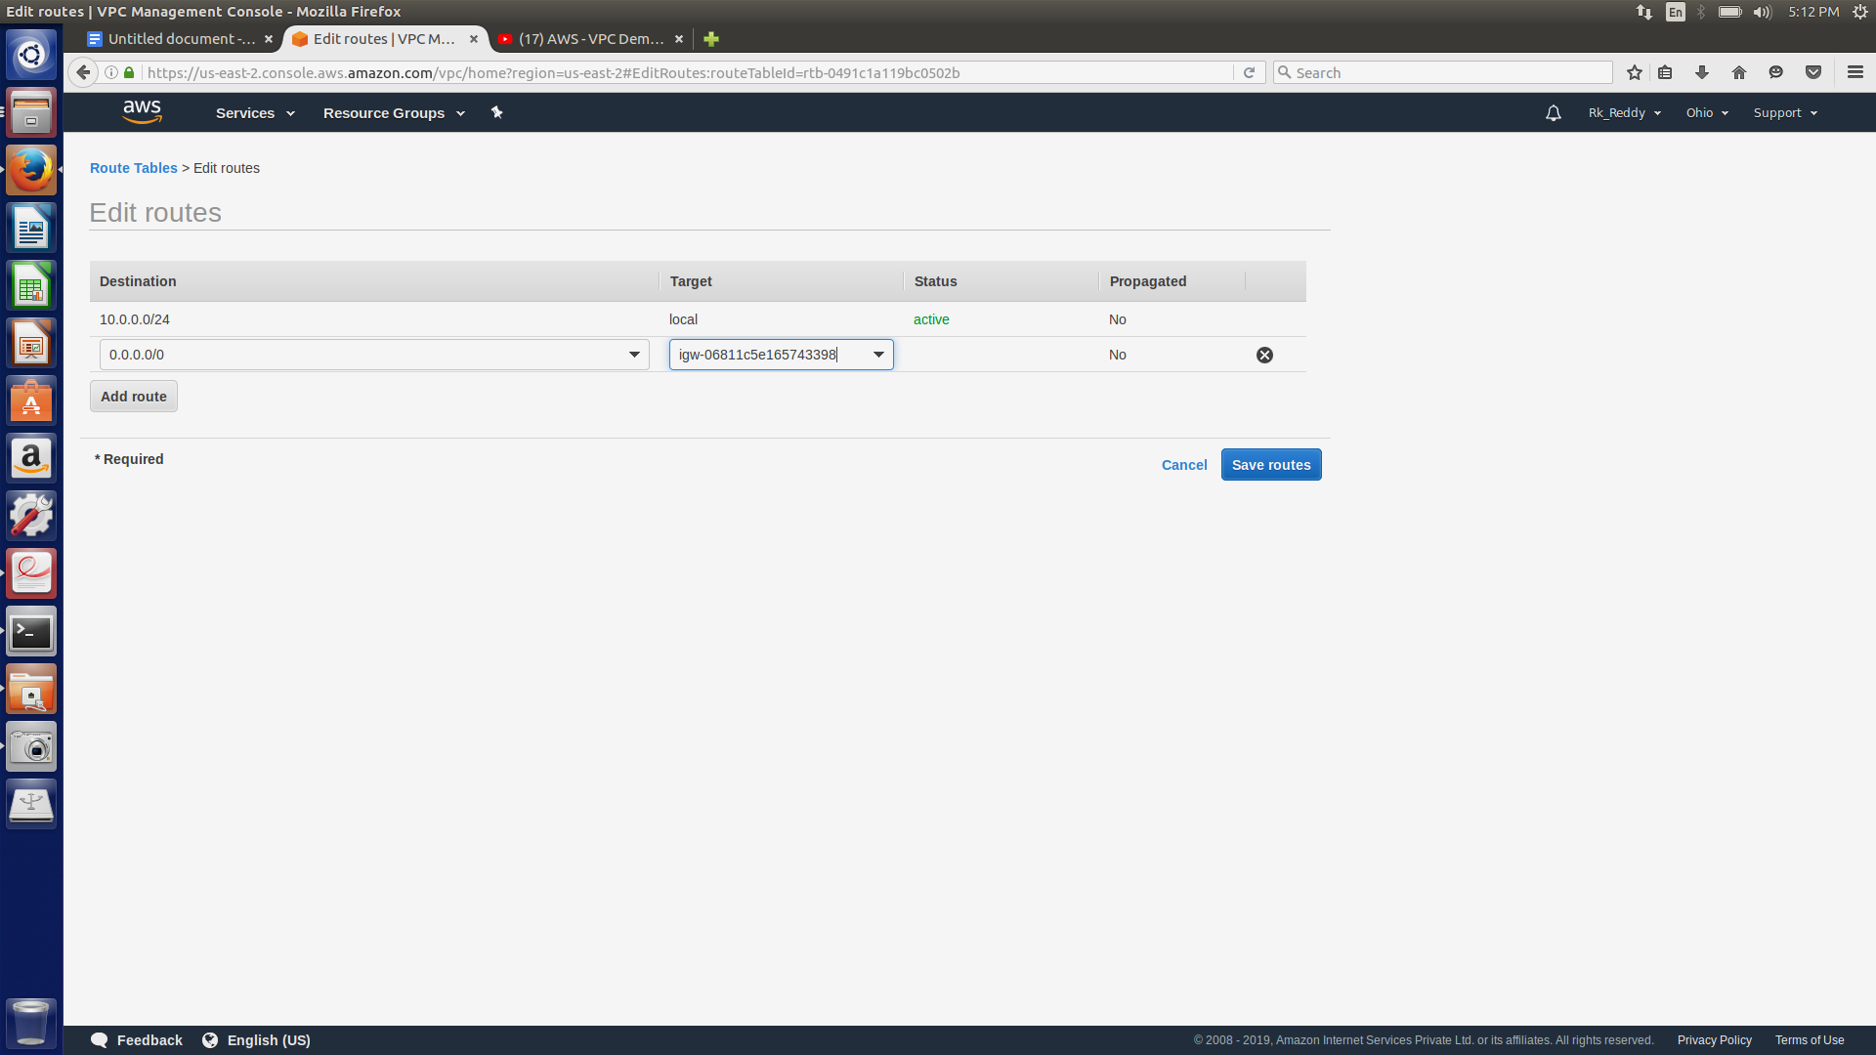

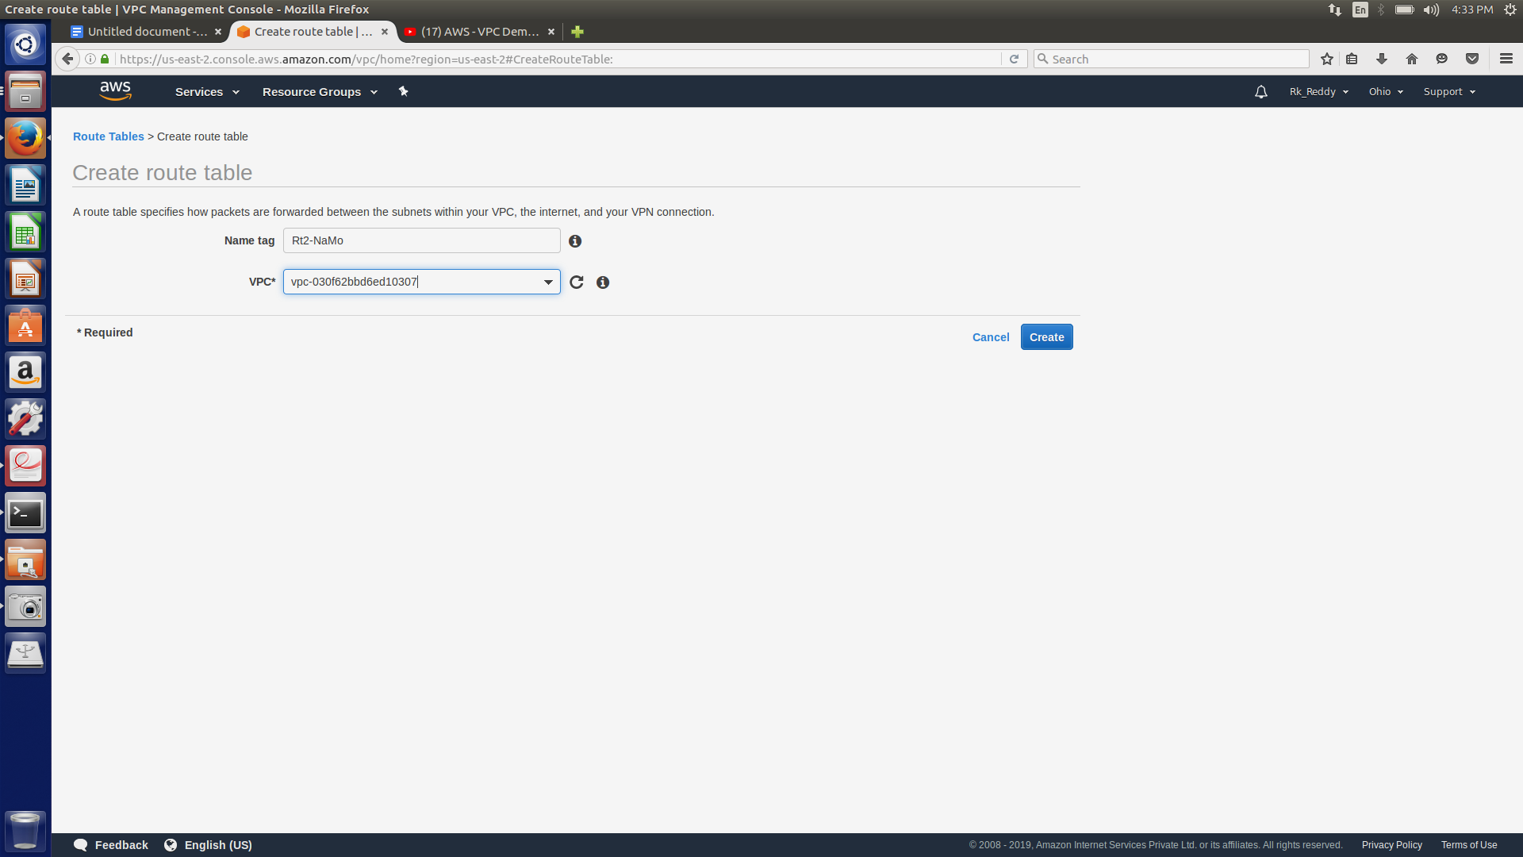

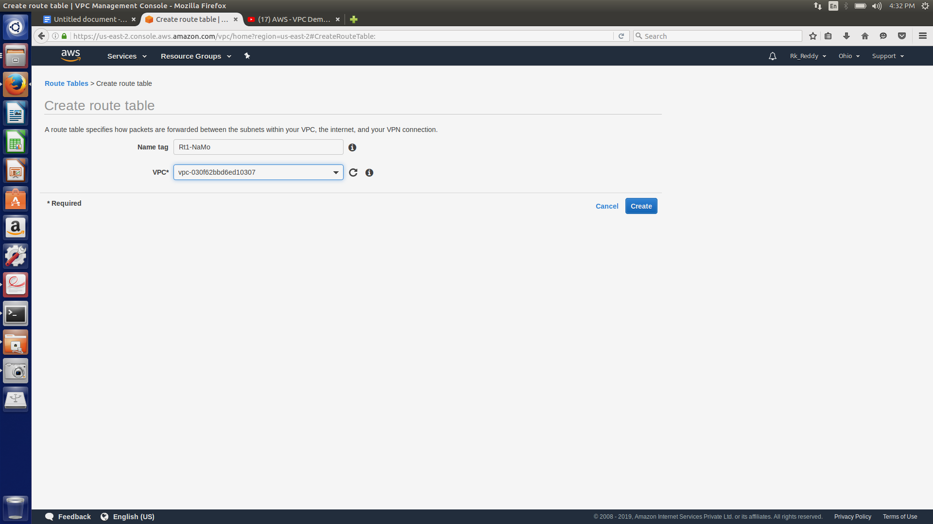

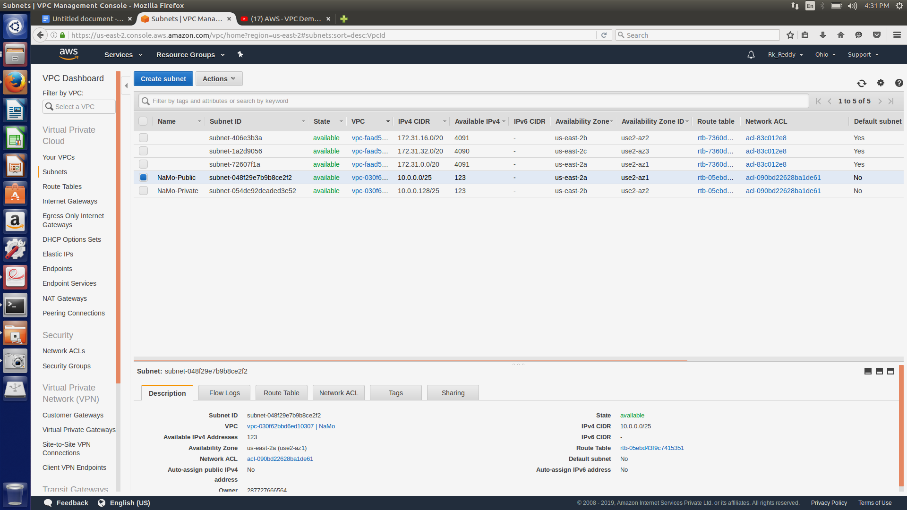

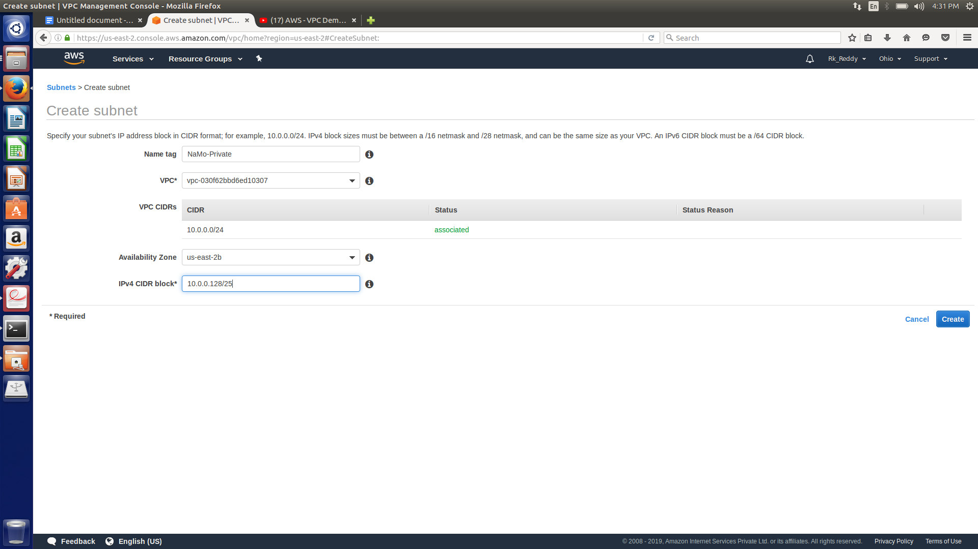

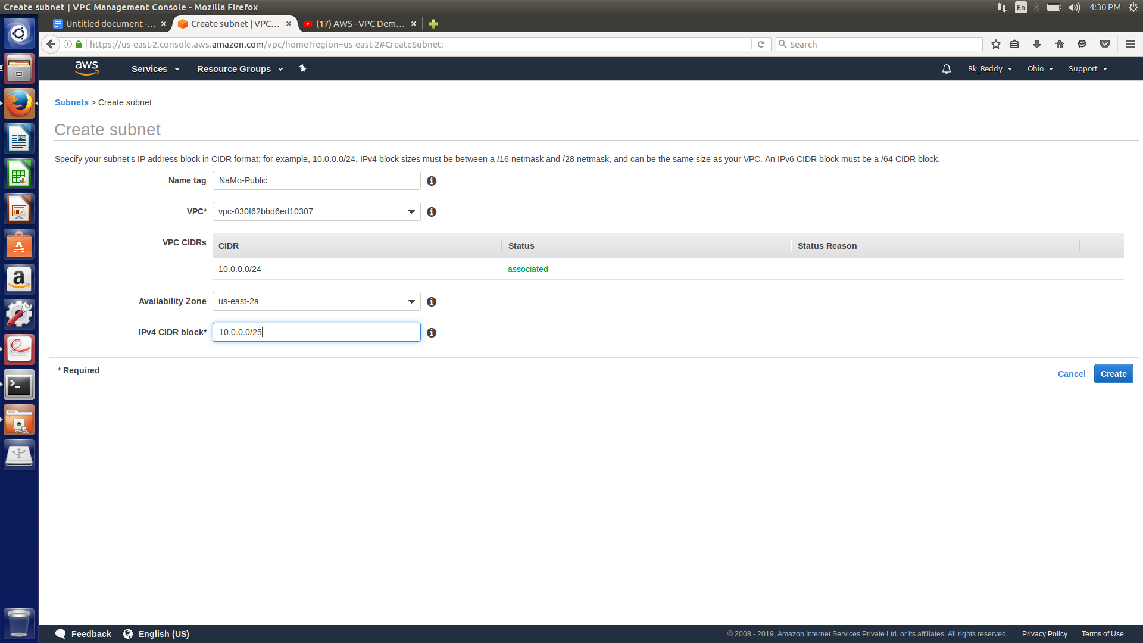

#### **Connecting to a private instance with public instance:**

In private instance edit the security group

Change the source in inbound rules

Instead of 0.0.0.0/0 type the name of the security group of public instance.



In NAT gateway we need to provide public subnet because with public subnet we can access internet using private instances.

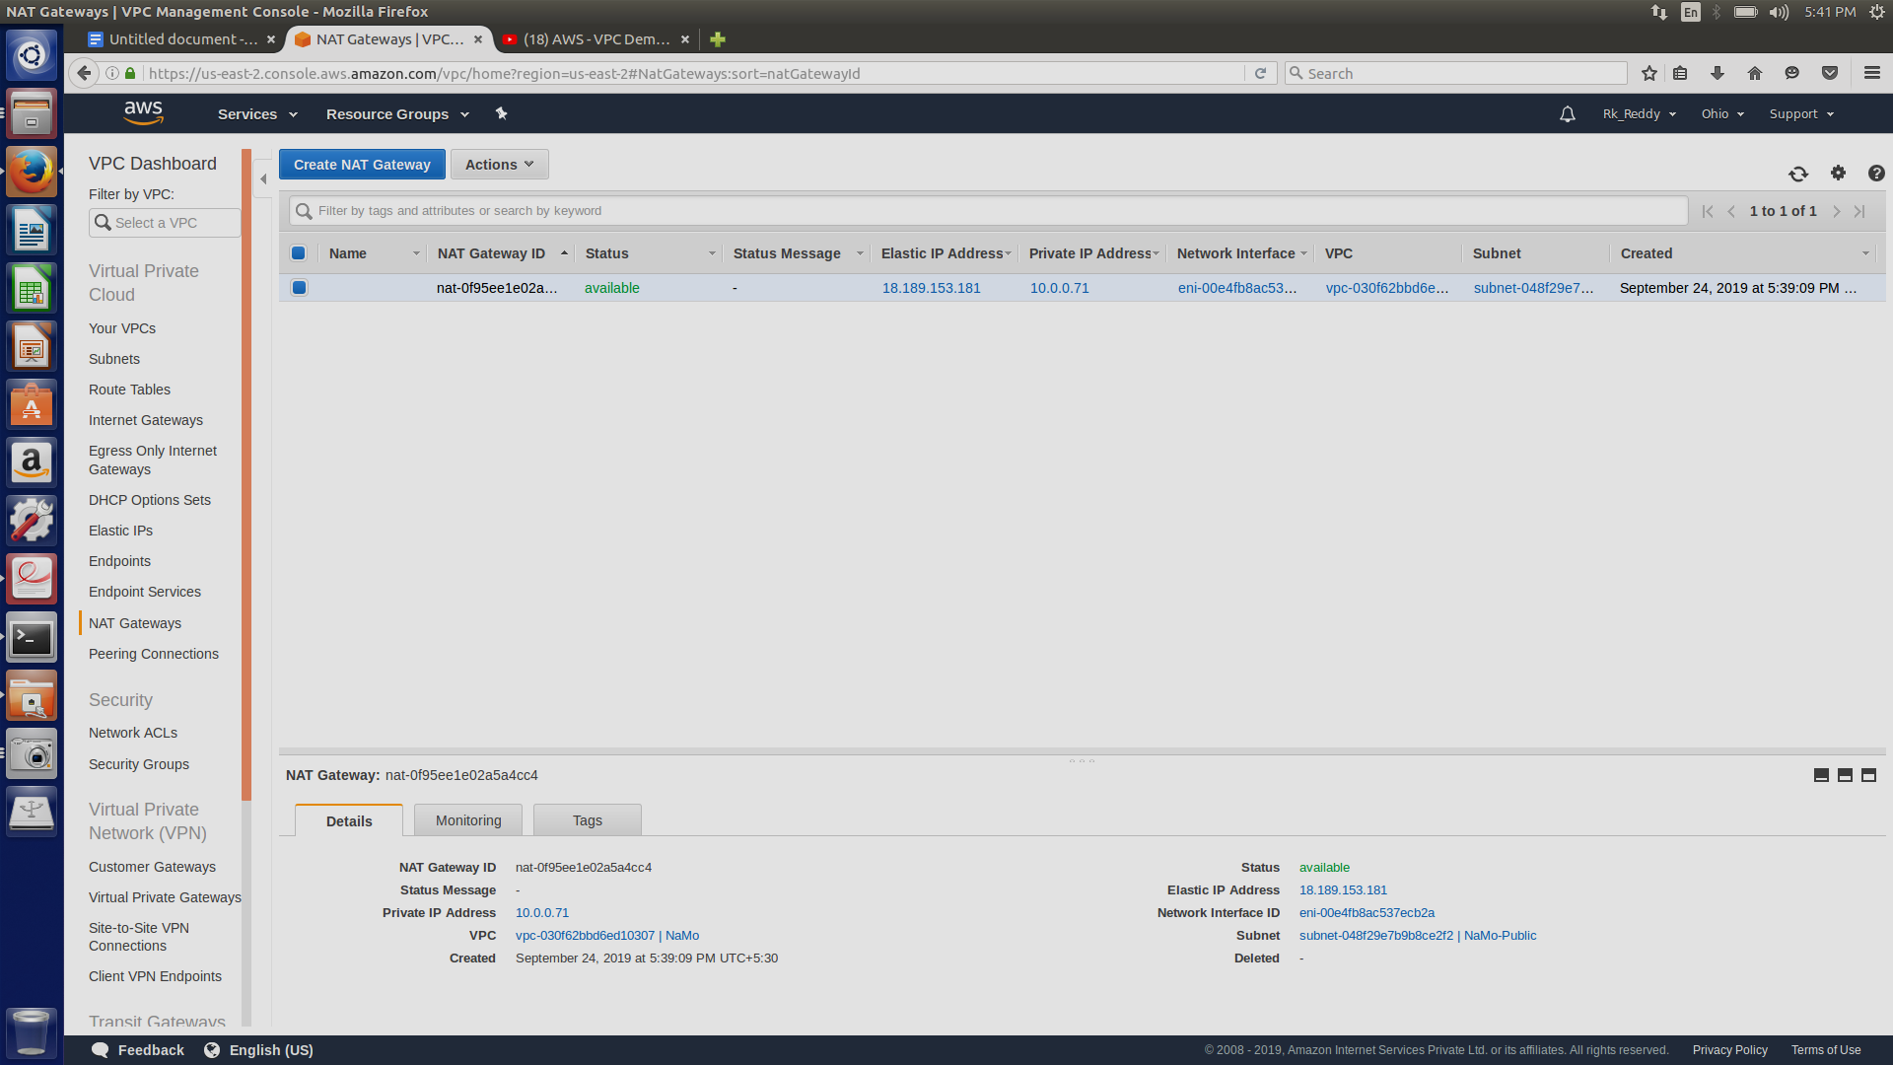

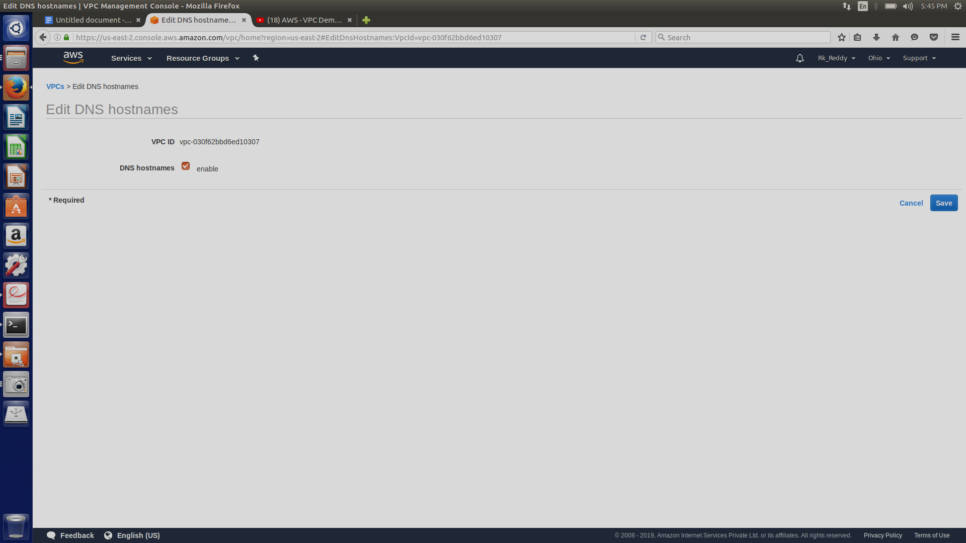

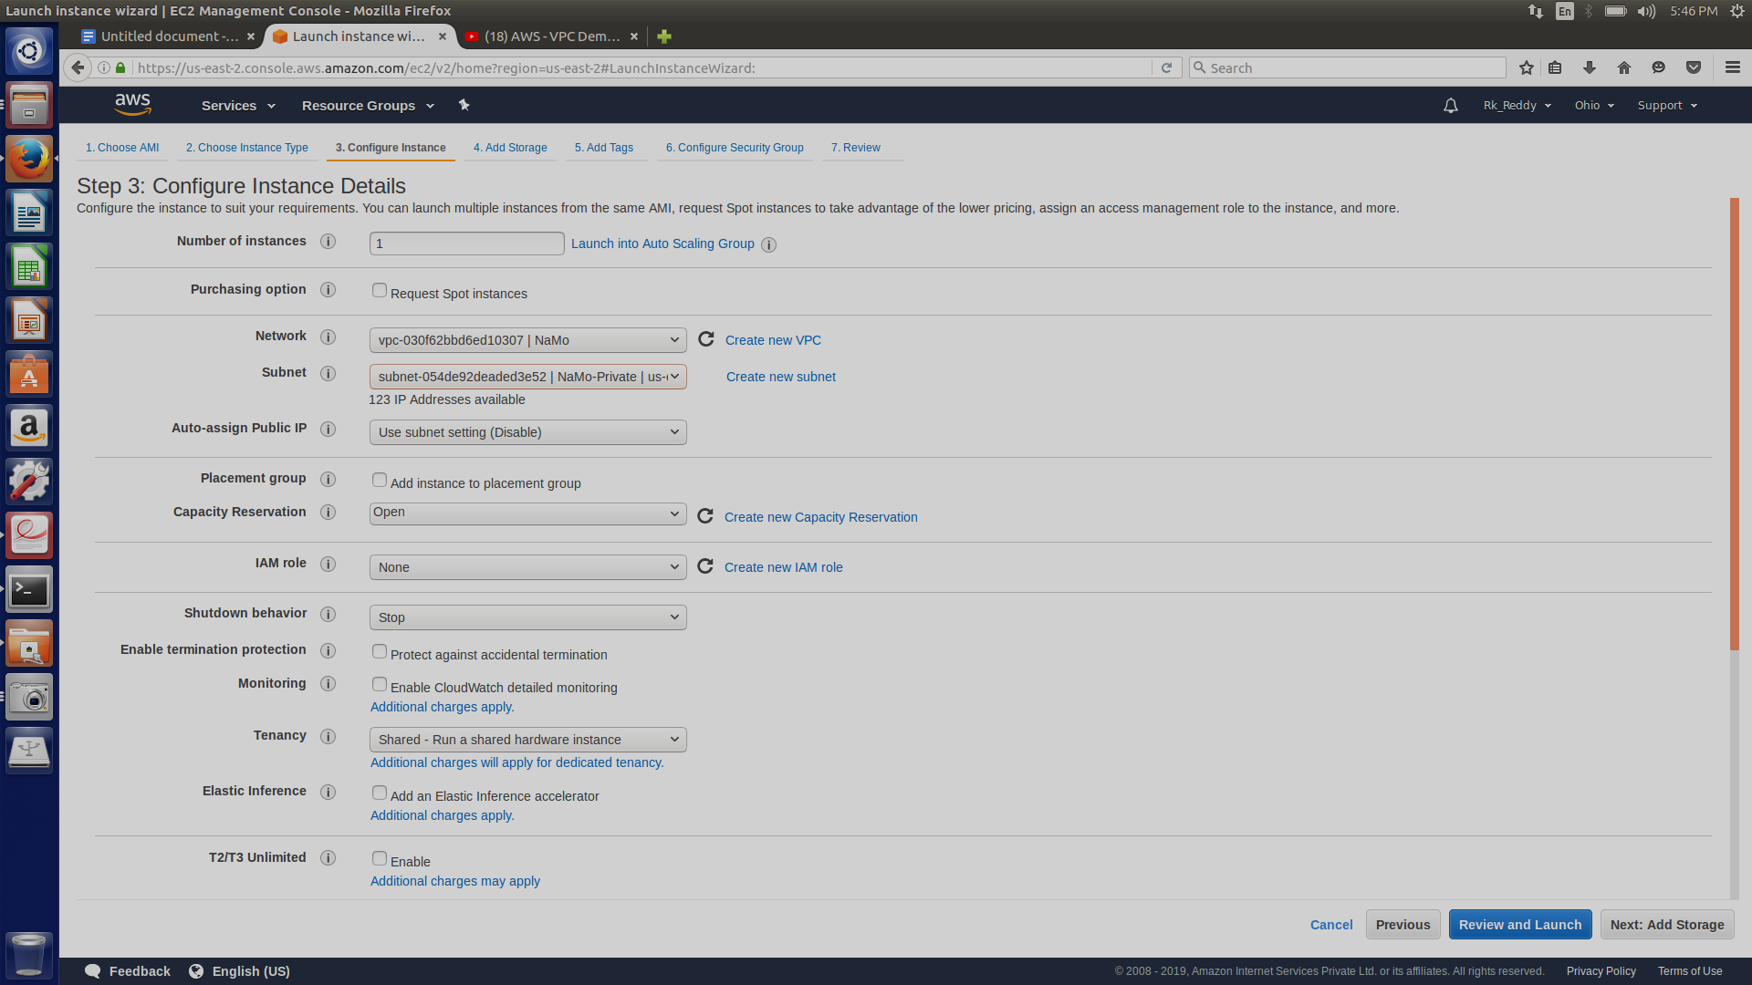

To connect to private instance type the following command:

ssh -o ProxyCommand=’ssh -i <keyfile> -W %h:%p ec2-user@<publicip_address>’ ec2-user@<privateip_address> -i <keyfile>

To check internet connectivity in private instance install any service.

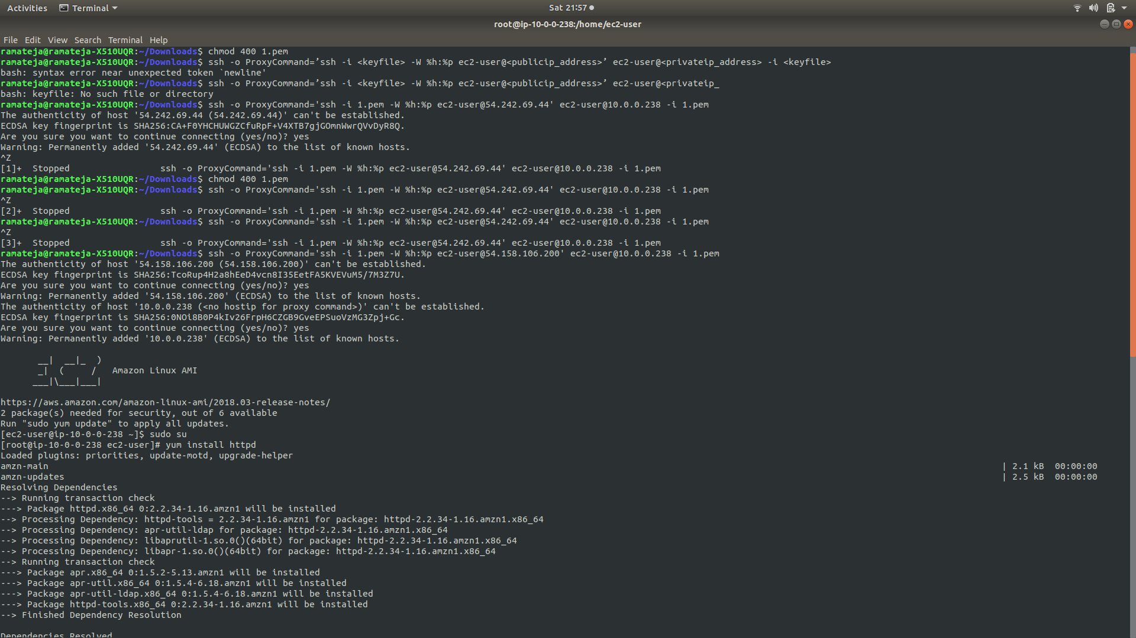

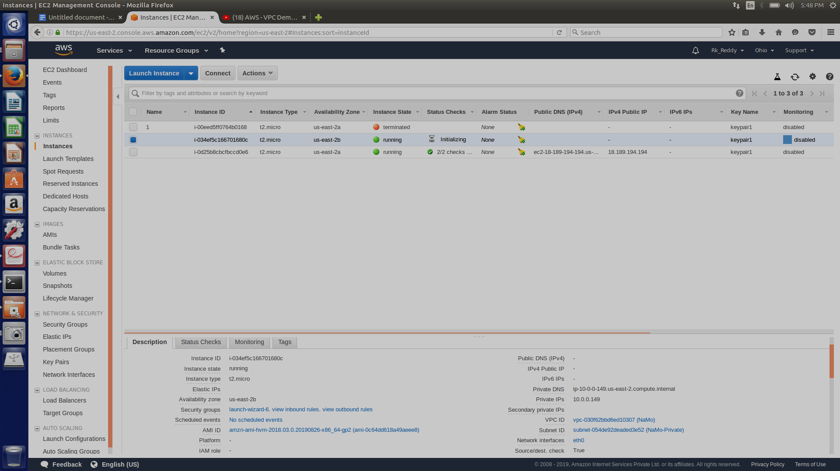

**Cloudfront**

Amazon CloudFront is a web service that speeds up distribution of your static and dynamic web content, such as .html, .css, .js, and image files, to your users. CloudFront delivers your content through a worldwide network of data centers called edge locations. When a user requests content that you're serving with CloudFront, the user is routed to the edge location that provides the lowest latency (time delay), so that content is delivered with the best possible performance.Amazon CloudFront is a web service that speeds up distribution of your static and dynamic web content, such as .html, .css, .js, and image files, to your users. CloudFront delivers your content through a worldwide network of data centers called edge locations. When a user requests content that you're serving with CloudFront, the user is routed to the edge location that provides the lowest latency (time delay), so that content is delivered with the best possible performance



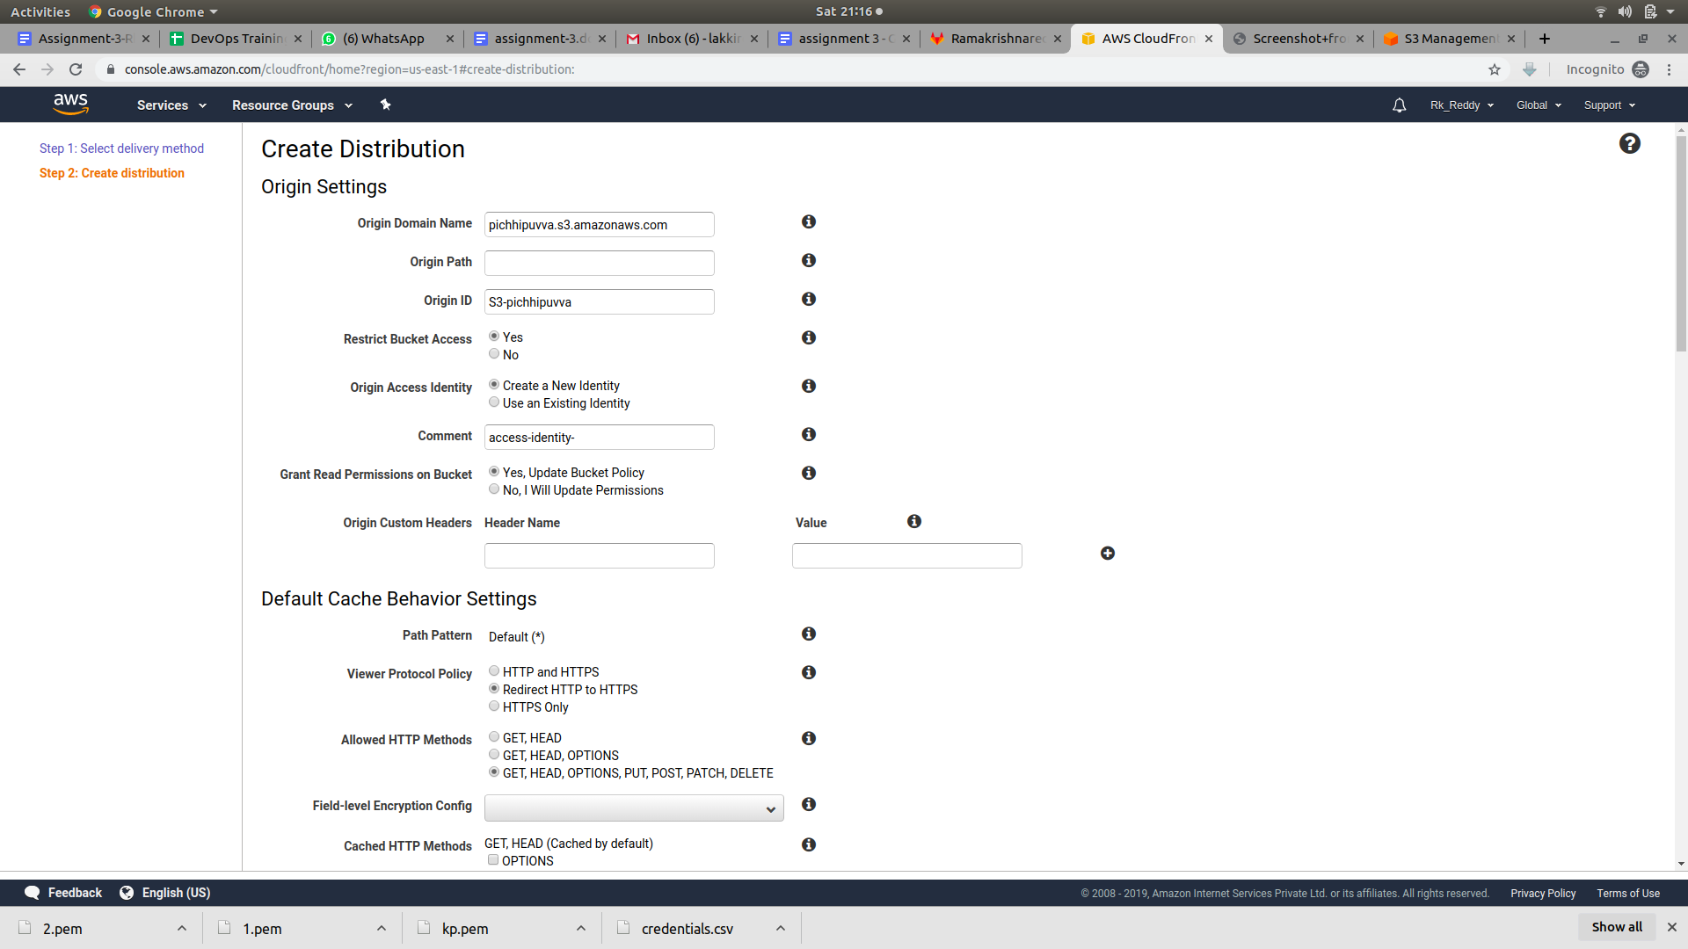

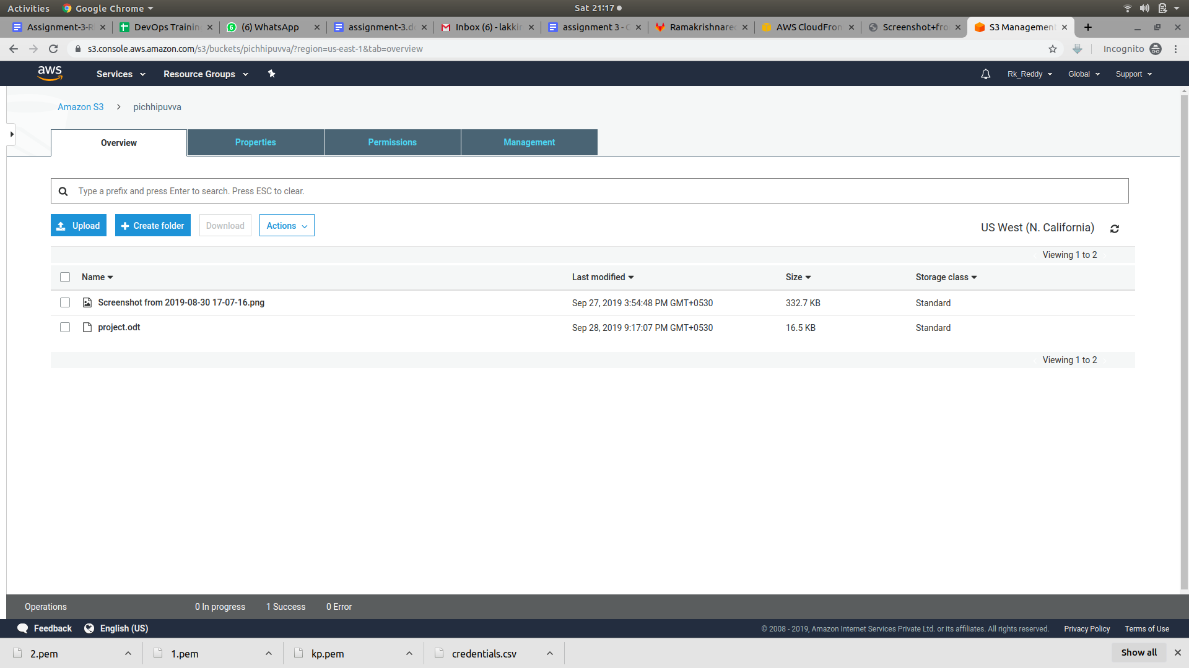

By using cloudfront we can access the file much faster than accessing it through s3 bucket .

But cloudfront will take some time to load for the first user but for the next users it will take much less time than accessing it though s3 bucket.

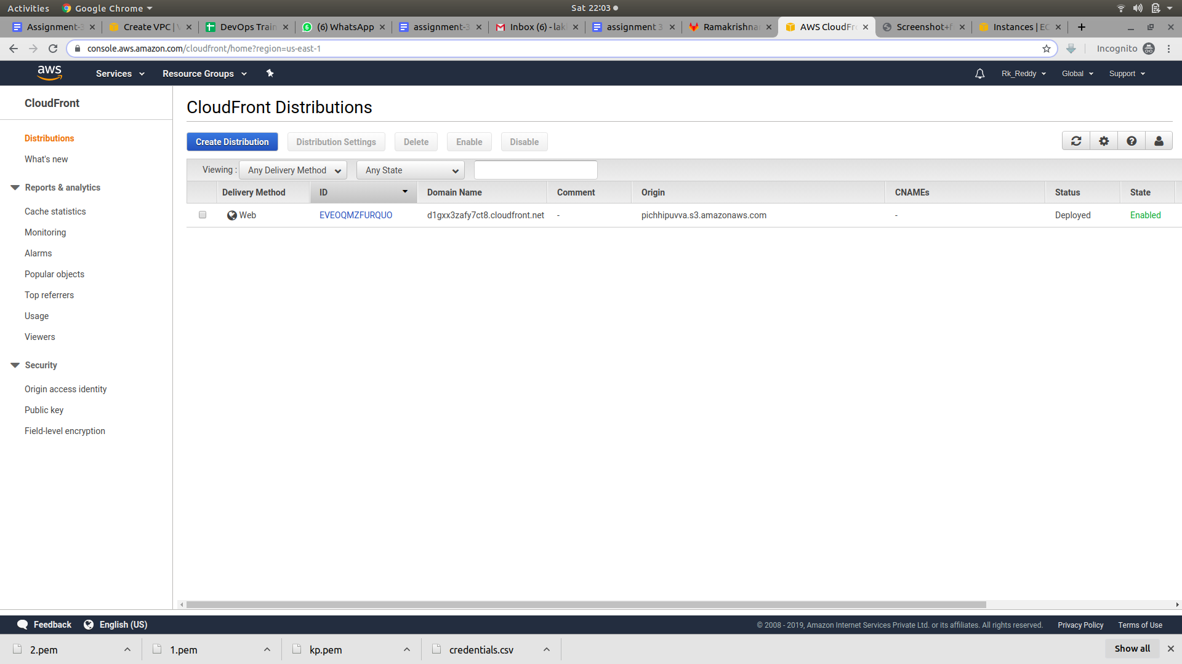

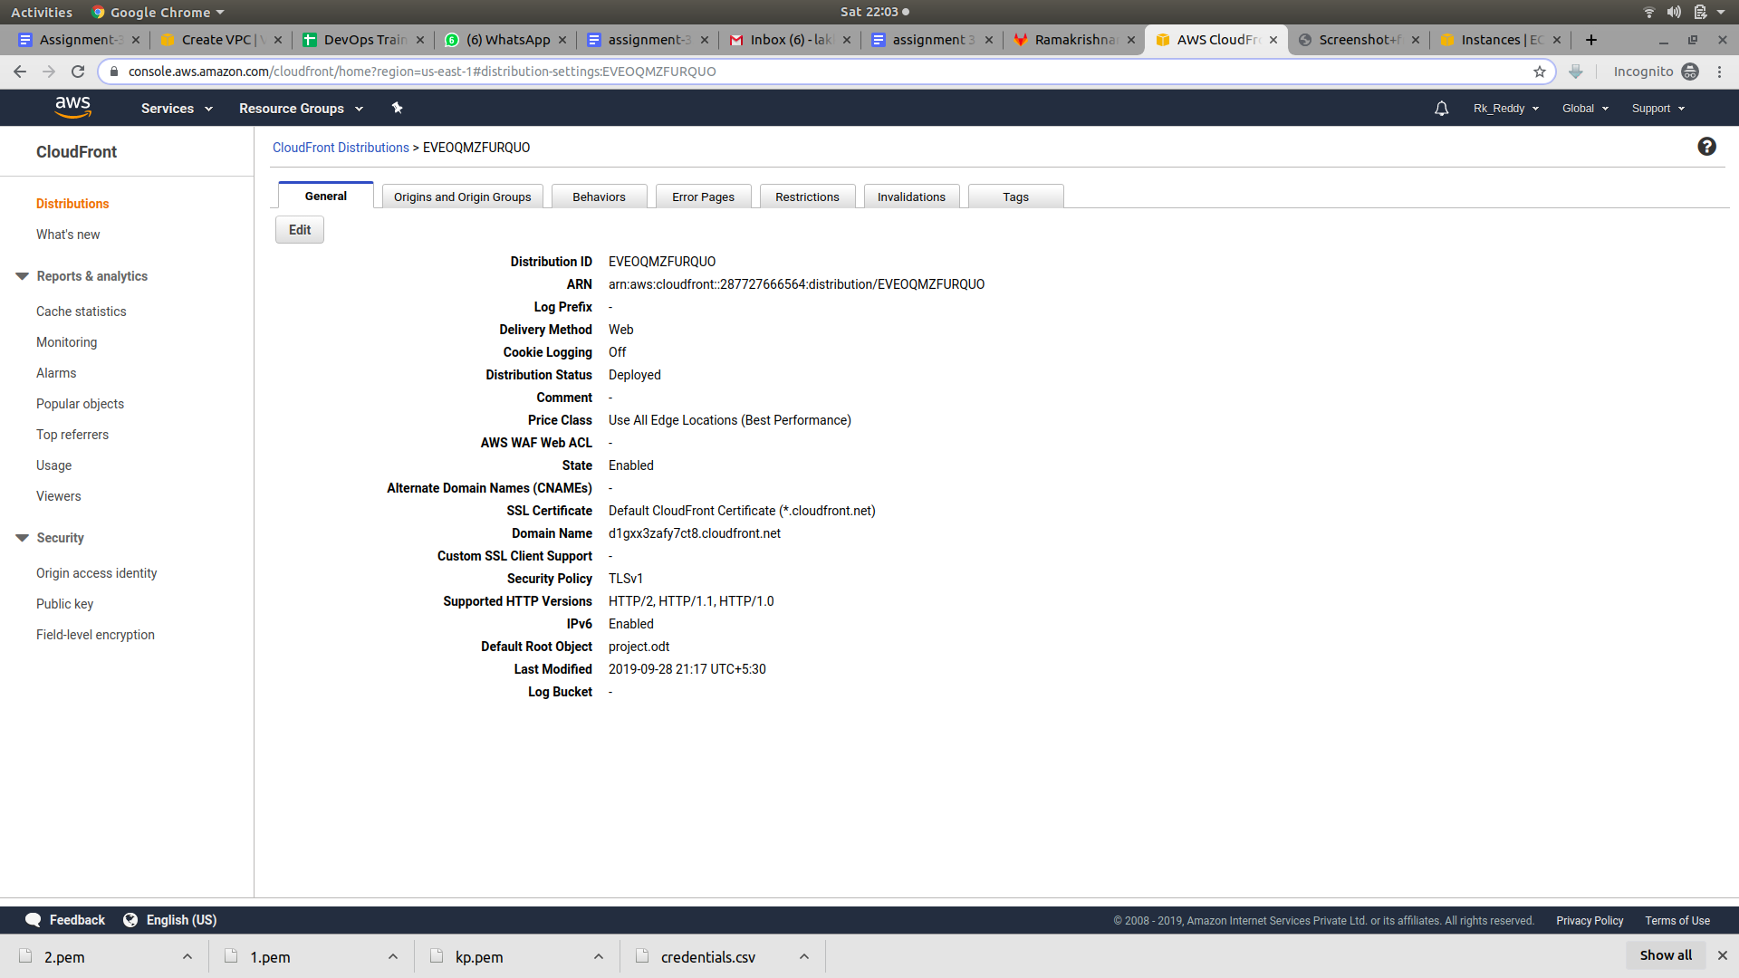

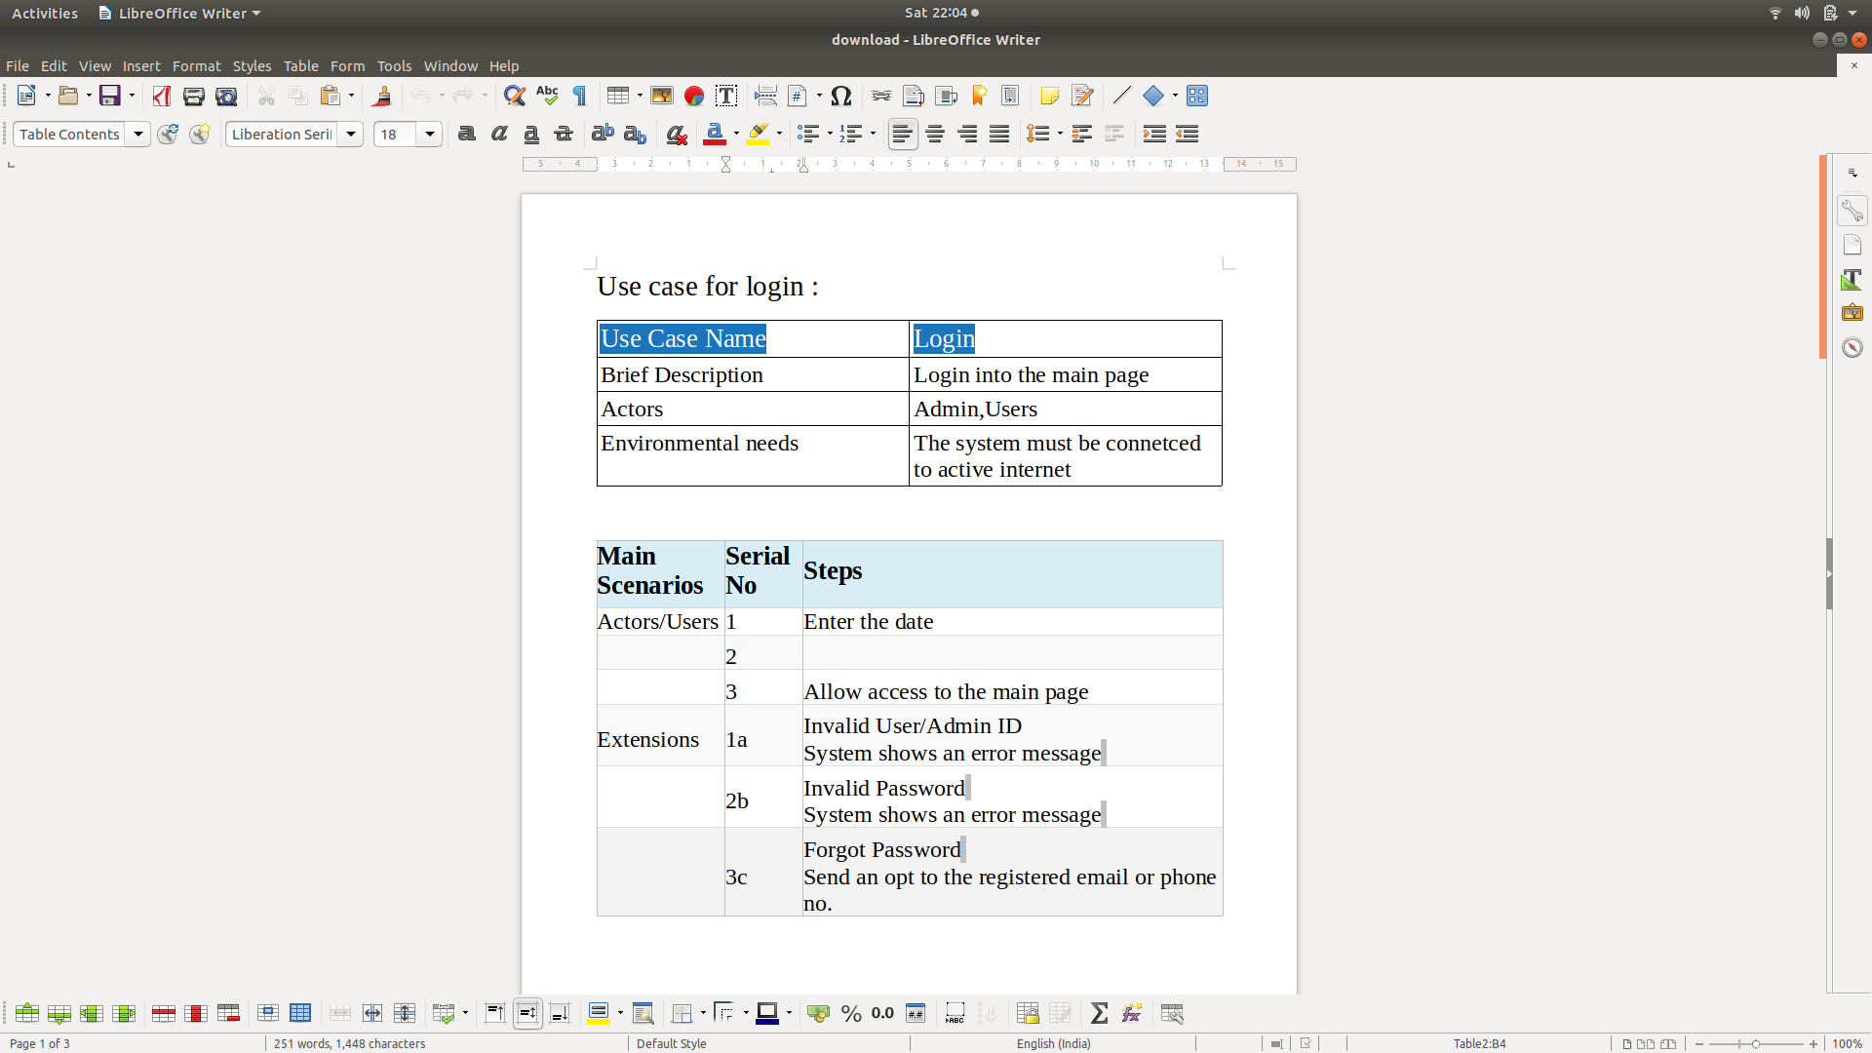

Above screenshot is the file which is downloaded from the internet by using the cloudfront.